



Incorporating the towns of Strydenburg and Hopetown
 Private bag X3 HOPETOWN 8750
Church Street HOPETOWN 8750
    (053) 2030005/8
Fax (053) 2030490
www.thembelihlemunicipality.co.za

 

31 January 2017

CONTENTS
CONTENTS 2
REVISED ANNUAL REPORT TEMPLATE 7
CHAPTER 1 – MAYOR’S FOREWORD AND EXECUTIVE SUMMARY 8
COMPONENT A: MAYOR’S FOREWORD 8
COMPONENT B: EXECUTIVE SUMMARY 11
1.1. MUNICIPAL MANAGER’S OVERVIEW 11
1.2. MUNICIPAL FUNCTIONS, POPULATION AND ENVIRONMENTAL OVERVIEW 14
1.3. SERVICE DELIVERY OVERVIEW 18
1.4. FINANCIAL HEALTH OVERVIEW 21
1.5. ORGANISATIONAL DEVELOPMENT OVERVIEW 24
1.6. AUDITOR GENERAL REPORT 24
1.7. STATUTORY ANNUAL REPORT PROCESS 25
CHAPTER 2 – GOVERNANCE 27
COMPONENT A: POLITICAL AND ADMINISTRATIVE GOVERNANCE 28
2.1 POLITICAL GOVERNANCE 28
2.2 ADMINISTRATIVE GOVERNANCE 30
COMPONENT B: INTERGOVERNMENTAL RELATIONS 32
2.3 INTERGOVERNMENTAL RELATIONS 32
COMPONENT C: PUBLIC ACCOUNTABILITY AND PARTICIPATION 33
2.4 PUBLIC MEETINGS 33
2.5 IDP PARTICIPATION AND ALIGNMENT 34
COMPONENT D: CORPORATE GOVERNANCE 35
2.6 RISK MANAGEMENT 36
2.7 ANTI-CORRUPTION AND FRAUD 37
2.8 SUPPLY CHAIN MANAGEMENT 37
2.9 BY-LAWS 38
2.10 WEBSITES 39
2.11 PUBLIC SATISFACTION ON MUNICIPAL SERVICES 40
CHAPTER 3 – SERVICE DELIVERY PERFORMANCE (PERFORMANCE REPORT PART I) 41
COMPONENT A: BASIC SERVICES 42
3.1. WATER PROVISION 43
3.2 WASTE WATER (SANITATION) PROVISION 50
3.3 ELECTRICITY 54
3.4 WASTE MANAGEMENT (THIS SECTION TO INCLUDE: REFUSE COLLECTIONS, WASTE DISPOSAL, STREET CLEANING AND RECYCLING) 58
3.5 HOUSING 63
3.6 FREE BASIC SERVICES AND INDIGENT SUPPORT 66
COMPONENT B: ROAD TRANSPORT 69
3.7 ROADS 70
3.8 TRANSPORT (INCLUDING VEHICLE LICENSING & PUBLIC BUS OPERATION) 73
3.9 WASTE WATER (STORMWATER DRAINAGE) 77
COMPONENT C: PLANNING AND DEVELOPMENT 79
3.10 PLANNING 81
3.11 LOCAL ECONOMIC DEVELOPMENT (INCLUDING TOURISM AND MARKET PLACES) 85
COMPONENT D: COMMUNITY & SOCIAL SERVICES 89
3.12 LIBRARIES; ARCHIEVES; MUSEUMS; GALLERIES; COMMUNITY FACILITIES; OTHER (THEATRES, ZOOS, ETC) 89
3.13 CEMETORIES AND CREMATORIUMS 92
3.14 CHILD CARE; AGED CARE; SOCIAL PROGRAMMES 95
COMPONENT E: ENVIRONMENTAL PROTECTION 98
3.15 POLLUTION CONTROL 98
3.16 BIO-DIVERSITY; LANDSCAPE (INCL. OPEN SPACES); AND OTHER (EG. COASTAL PROTECTION) 101
COMPONENT F: HEALTH 104
3.17 CLINICS 104
3.18 AMBULANCE SERVICES 107
3.19 HEALTH INSPECTION; FOOD AND ABBATOIR LICENSING AND INSPECTION; ETC 110
COMPONENT G: SECURITY AND SAFETY 113
3.20 POLICE 113
3.21 FIRE 116
3.22 OTHER (DISASTER MANAGEMENT, ANIMAL LICENCING AND CONTROL, CONTROL OF PUBLIC NUISANCES AND OTHER) 119
COMPONENT H: SPORT AND RECREATION 122
3.23 SPORT AND RECREATION 122
COMPONENT I: CORPORATE POLICY OFFICES AND OTHER SERVICES 125
3.24 EXECUTIVE AND COUNCIL 125
3.25 FINANCIAL SERVICES 128
3.26 HUMAN RESOURCE SERVICES 131
3.27 INFORMATION AND COMMUNICATION TECHNOLOGY (ICT) SERVICES 134
3.28 PROPERTY; LEGAL; RISK MANAGEMENT AND PROCUREMENT SERVICES 137
COMPONENT J: MISCELLANEOUS 140
COMPONENT K: ORGANISATIONAL PERFOMANCE SCORECARD 140
CHAPTER 4 – ORGANISATIONAL DEVELOPMENT PERFORMANCE 141
(PERFORMANCE REPORT PART II) 141
COMPONENT A: INTRODUCTION TO THE MUNICIPAL PERSONNEL 141
4.1 EMPLOYEE TOTALS, TURNOVER AND VACANCIES 141
COMPONENT B: MANAGING THE MUNICIPAL WORKFORCE 143
4.2 POLICIES 144
4.3 INJURIES, SICKNESS AND SUSPENSIONS 145
4.4 PERFORMANCE REWARDS 148
COMPONENT C: CAPACITATING THE MUNICIPAL WORKFORCE 149
4.5 SKILLS DEVELOPMENT AND TRAINING 150
COMPONENT D: MANAGING THE WORKFORCE EXPENDITURE 152
4.6 EMPLOYEE EXPENDITURE 152
CHAPTER 5 – FINANCIAL PERFORMANCE 155
COMPONENT A: STATEMENTS OF FINANCIAL PERFORMANCE 155
5.1 STATEMENTS OF FINANCIAL PERFORMANCE 156
5.2 GRANTS 158
5.3 ASSET MANAGEMENT 159
5.4 FINANCIAL RATIOS BASED ON KEY PERFORMANCE INDICATORS 161
COMPONENT B: SPENDING AGAINST CAPITAL BUDGET 166
5.5 CAPITAL EXPENDITURE 166
5.6 SOURCES OF FINANCE 167
5.7 CAPITAL SPENDING ON 5 LARGEST PROJECTS 168
5.8 BASIC SERVICE AND INFRASTRUCTURE BACKLOGS – OVERVIEW 169
COMPONENT C: CASH FLOW MANAGEMENT AND INVESTMENTS 170
5.9 CASH FLOW 171
5.10 BORROWING AND INVESTMENTS 172
5.11 PUBLIC PRIVATE PARTNERSHIPS 174
COMPONENT D: OTHER FINANCIAL MATTERS 174
5.12 SUPPLY CHAIN MANAGEMENT 174
5.13 GRAP COMPLIANCE 174
CHAPTER 6 – AUDITOR GENERAL AUDIT FINDINGS 175
COMPONENT A: AUDITOR-GENERAL OPINION OF FINANCIAL STATEMENTS Year -1 175
6.1 AUDITOR GENERAL REPORTS Year -1 (Previous year) 175
COMPONENT B: AUDITOR-GENERAL OPINION YEAR 0 (CURRENT YEAR) 176
6.2 AUDITOR GENERAL REPORT YEAR 0 176
GLOSSARY 187
APPENDICES 190
APPENDIX A – COUNCILLORS; COMMITTEE ALLOCATION AND COUNCIL ATTENDANCE 190
APPENDIX B – COMMITTEES AND COMMITTEE PURPOSES 191
APPENDIX C –THIRD TIER ADMINISTRATIVE STRUCTURE 192
APPENDIX D – FUNCTIONS OF MUNICIPALITY / ENTITY 194
APPENDIX E – WARD REPORTING 195
APPENDIX F – WARD INFORMATION 196
APPENDIX G – RECOMMENDATIONS OF THE MUNICIPAL AUDIT COMMITTEE YEAR 0 197
APPENDIX H – LONG TERM CONTRACTS AND PUBLIC PRIVATE PARTNERSHIPS 197
APPENDIX I – MUNICIPAL ENTITY/ SERVICE PROVIDER PERFORMANCE SCHEDULE 198
APPENDIX J – DISCLOSURES OF FINANCIAL INTERESTS 199
APPENDIX K: REVENUE COLLECTION PERFORMANCE BY VOTE AND BY SOURCE 200
APPENDIX K (i): REVENUE COLLECTION PERFORMANCE BY VOTE 200
APPENDIX K (ii): REVENUE COLLECTION PERFORMANCE BY SOURCE 200
APPENDIX L: CONDITIONAL GRANTS RECEIVED: EXCLUDING MIG 201
APPENDIX M: CAPITAL EXPENDITURE – NEW & UPGRADE/RENEWAL PROGRAMMES 202
APPENDIX M (i): CAPITAL EXPENDITURE - NEW ASSETS PROGRAMME 202
APPENDIX M (ii): CAPITAL EXPENDITURE – UPGRADE/RENEWAL PROGRAMME 204
APPENDIX N – CAPITAL PROGRAMME BY PROJECT YEAR 0 206
APPENDIX O – CAPITAL PROGRAMME BY PROJECT BY WARD YEAR 0 207
APPENDIX P – SERVICE CONNECTION BACKLOGS AT SCHOOLS AND CLINICS 208
APPENDIX Q – SERVICE BACKLOGS EXPERIENCED BY THE COMMUNITY WHERE ANOTHER SPHERE OF GOVERNMENT IS RESPONSIBLE FOR SERVICE PROVISION 209
APPENDIX R – DECLARATION OF LOANS AND GRANTS MADE BY THE MUNICIPALITY 209
APPENDIX S – NATIONAL AND PROVINCIAL OUTCOMES FOR LOCAL GOVERNMENT 210
VOLUME II: ANNUAL FINANCIAL STATEMENTS 211

REVISED ANNUAL REPORT TEMPLATE

The purpose of this revised Annual Report template is to address the need expressed by a number of municipalities for assistance in the preparation and development of improved content and quality of Municipal Annual Reports. This template provides an update to the MFMA Circular No. 11, issued in January 2005.

This template gives effect to the legal framework requirement, concepts and principals espoused in the White Paper on Local Government and Improving Government Performance. It reflects the ethos of public accountability. The content gives effect to information required for better monitoring and evaluation of government programmes in support of policy decision making. The template provides an improved overview of municipal affairs by combining the performance report data required under Municipal Systems Act Section 46 with annual report data referred to in that Act and in the MFMA.

The revised template makes its contribution by forging linkages with the Integrated Development Plan, Service Delivery and Budget Implementation Plan, Budget Reforms, In-year Reports, Annual Financial Statements and Performance Management information in municipalities. This coverage and coherence is achieved by the use of interlocking processes and formats.

The revised template relates to the Medium Term Strategic Framework particularly through the IDP strategic objectives; cross cutting nature of services offered by different spheres of government, municipal service outcome indicators; and the contextual material as set out in Chapters 3, 4 & 5. It also provides information on good management practice in Chapter 4; risk management in Chapter 2; and Supply Chain Management in Chapter 5; and addresses the Auditor-General’s Report, dealing with Financial and Performance Management arrangements in Chapter 6. This opens up greater possibilities for financial and non financial comparisons between municipalities and improved value for money.

The revised template provides information on probity, including: anti-corruption strategies; disclosure of financial interests by officials and councillors; disclosure of grants by external parties, disclosure of loans and grants by municipalities. The appendices talk to greater detail including disaggregated information on municipal wards, among others. Notes are included throughout the format to assist the compiler to understand the various information requirements.

The financial years contained in this template are explained as follows:

- Year -1: The previous financial year;
- Year 0: The financial year of reporting;
- Year 1: The following year, mostly requires future targets; and
- The other financial years will follow a similar sequence as explained above.

We wish to express our gratitude to the members of the Annual Report Reference Group, consisting of national, provincial and municipal officials for their inputs and support throughout the development of this document.

MFMA Implementation Unit, National Treasury July 2012

CHAPTER 1 – MAYOR’S FOREWORD AND EXECUTIVE SUMMARY

COMPONENT A: MAYOR’S FOREWORD

MAYOR’S FOREWORD

Introduction

It gives me great pleasure to present Thembelihle Local Municipality’s 2015/2016 Annual Report covering the period 1 July 2015 to 30 June 2016. This report tracks the Municipality’s operational performance in the context of the priorities reflected in its approved 2015/16 Integrated Development Plan (IDP) and 2015/16 Service Delivery and Budget Implementation Plan (SDBIP).

In this Annual Report, the municipality presents its achievements, challenges faced during the financial year against the strategic objectives as set out in the IDP and SDBIP.

Vision

The 2015/16 financial year marked the end of the 5-year term of office for the current municipal council. The council remained focused on addressing the 5 developmental local government key performance areas, viz.:

• Infrastructure and Service Delivery:
• Institutional Transformation and Development;
• Local Economic Development and Planning;
• Financial Viability, and
• Good Governance & Public Participation.

The municipality continues to face severe challenges with regards to its finances but we remain positive that change will come in the near future. In the interim, we as a municipality will continue to stand united notwithstanding the challenges we face on a daily basis. It is against that backdrop that we announce that the municipality achieved a qualified audit opinion for the second consecutive year and moving away from previous disclaimer, however we renewed our strive towards an improved qualified audit opinion in near future.

Similar to most municipalities throughout South Africa, Thembelihle Local Municipality also faces challenges with regards to unemployment, poverty and inequality. In this regard the council continues to prioritize job creation especially through the Expanded Public Works Programme (EPWP) projects.

Mission

To improve the lives of citizens of Thembelihle Municipal area through:

• Quality Service Delivery
• Have a two-way approach to communication and service
• Ensuring a safe and enabling environment for economic growth
• Ensuring integrated sustainable human settlements
• Ensuring equal opportunities

Key Policy Developments

This report shows that the municipality has implemented existing as well as a number of new policies in order to have maximum impact and success in its service delivery programs. The municipality is aware of the current backlog of delivery of services to the community and is utilizing all available resources to clear it. This will take time and during that time, it is my plea the community remain patient with the council and to assist the council to reach the desired levels of service delivery.

Key Service Delivery Improvements

Roads and infrastructure

• The municipality was and is in the process of developing and implementing the policies required, due to cash constraints it is difficult to develop all the policies within one year. 2015/16 financial year process is evidence that the policies are being developed and in process.
• Routine maintenance is performed on roads on a regular basis by way of EPWP.

Water infrastructure

• The municipality is currently busy with the following projects with regards to water infrastructure:
o Ground Water Project in Strydenburg
o Upgrading of Roads and storm water in Steynville
• Report on blue drop performance rating – The Department of Water and Sanitation has confirmed verbally that the blue and green drop assessments has not yet been performed by them for the 2015/16 financial year.

Sanitation

• Similar to water infrastructure, the municipality is experiencing a backlog which consists of 200 households in 7 De Laan. The backlog is attributed to a lack of funding.

Public Participation

During the year, various methods and/or processes were used to increase public awareness on service availability engage public in decision making and improve accountability to communities.

Public documents were posted on the municipality’s website and the public invited to make comments and provide inputs thereto.

Future Actions

Thembelihle Local Municipality is not an island and must ensure well co-ordinated strategic relationship with other spheres of government and that is why Thembelihle Local Municipality’s Integrated Development Plan must be aligned to other key planning and policy instruments for the national, provincial and district government levels. One of the key objectives of Integrated Development Planning (IDP) is to ensure alignment between National and provincial priorities, policies and strategies which include the following:

• Millennium Development Goals
• National Development Goals (Vision 2030)

Water and Sanitation is ranked as the major challenges of Thembelihle Municipality. This stems from the current reality that in most parts of the Thembelihle Municipality, water and sanitation services is meeting the required standards. Limited wealth of skills and experience in the water and sanitation discipline though training courses and mentoring initiatives are provided to enhance the capacity of processors to operate and man the water and sanitation infrastructure networks. Initiatives committed whereby service delivery will be improved over the next few years.

Agreements / Partnerships

The municipality does not have any twinning agreements with other towns currently in place however the matter has been raised and is currently an option which council strongly believes should be pursued to assist the municipality in fulfilling its constitutional mandate.

Conclusion – Final thoughts on the year

The achievements reflected in this annual report are a direct result of the combined efforts of the political leadership, administrative management and all municipal officials who work tirelessly to ensure that the services delivery needs of residents of Thembelihle Local Municipality are met.

In conclusion, I therefore call on Council, the administration and all the residents of the municipality to join me on this demanding, challenging, but conquerable journey to make Thembelihle Local municipality a better place for all citizens that reside here.

B Mpamba

Mayor/Executive Mayor

T 1.0.1

COMPONENT B: EXECUTIVE SUMMARY

MUNICIPAL MANAGER’S OVERVIEW – 2015/16

MUNICIPAL MANAGER’S OVERVIEW

The municipality’s Annual Report for the 2015/16 Financial Year provides an overview of the work undertaken in the year under review, outlining both its highlights and challenges.

This year under review is also the conclusion of the current five-year term with the Municipal Elections taking place on the 3 August 2016. Thembelihle obtained a second consecutive qualified audit, which improved from a disclaimer in the past. This resulted on even stronger emphasis and focus being placed on our audit action plan, aimed at resolving findings raised by the auditors.

Thembelihle Local Municipality is a local municipality operating under the Pixley Ka Seme District Municipality in the Northern Cape province of South Africa. Thembelihle is a Xhosa name meaning “good hope”. The municipality is established and operates in terms of Chapter 7 of the South African Constitution. Section 152(1) outlines various objects of local government and it is on these objects that this municipality governs and serves its community in a democratic manner.

The municipality has five service departments, namely, the Municipal Manager’s office, Finance Department, Technical department, Community Services Department and the Corporate Services department. When these departments’ positions are fully filled service delivery should be of high standard, however, there still exists some vacancies at various levels within the municipality.

According to the results of Census 2011, the municipality was divided into 4 regions, viz. Hopetown, Strydenburg, Orania and a number of other rural areas all of whom are collectively referred to as Thembelihle NU. During the demarcation process the following entities were amalgamated under this new municipal area:
• Hopetown;
• Strydenburg;
• Rural areas.
• Surrounding Farms

(The outcome of Orania’s dispute to be a self-governed town/establishment has not yet been decided upon and the uncertainty still remains as to where they will be demarcated.)

The Council appointed the Municipal Manager as IDP Manager and would be tasked to manage the IDP and make sure that the IDP is implemented. The Integrated Development Plan (IDP) therefore is a five-year development blueprint for a municipality; it is the principal strategic planning instrument which guides and informs all planning, budgeting, investment, development, management and implementation in the medium-term decision-making.

As previously alluded to, Thembelihle municipality like all other municipalities its size in South Africa, is continuously challenged to perform within the necessary standards as stipulated by the various legislations applicable to Local Government. The challenges manifest themselves in the form of capacity constraints both in terms of human capital and finance. It is generally accepted that the most qualified and most capable people will not opt to work in the small municipalities because of the lower salaries that they offer as well as the lack of social life after work. It therefore remains a challenge to us that our performance must remain at the required level while we are using the staff that does not have the same competency as the other better resourced municipalities.

In the 2015-16 audit of the annual financial statements by the office of the Auditor-General South Africa, the municipality was able to achieve a qualified audit opinion. This is attributed to various factors some, the details of which can be found on the Chief Financial Officer’s report.

Herewith a few general issues which the readers of this annual report should take note of:

- The municipality did not have an audit committee for the 2015/2016 financial year. However, the audit and risk committee member positions have been advertised again in the newspaper on 27 July 2016 per the normal recruitment processes. The candidates will be evaluated and if suitable candidates can be appointed they will fill the audit and risk committee functions as prescribed by legislation. Corporate Services is in process with the next step of the normal recruitment process.
- The municipality does not currently have a full staff complement with regards to Performance Management and as such, a functional performance management system is not in place. The Human Resources section is working towards capacitating the Performance Management Unit (and all other critical vacant positions within the municipality).
- The previous CFO of the municipality, Mr JG Butterworth tendered his resignation and his employment with the municipality terminated on 31 March 2016. The vacant post was then advertised, suitable applicants shortlisted and interviews held. Council approved the appointment of a CFO during the council meeting held on Monday, 29 February 2016. The CFO was duly appointed and commenced duty on 01 April 2016. The then CFO assumed duties on 4 April 2016. To note that the CFO has tendered his resignation and his last working day will be 13 July 2016.
- An Intern retention strategy developed and approved by MFIP Steering Committee on 16 March 2016.
- The SCOA Implementation Plan has been compiled and SCOA Steering Committee Meetings are held.

The municipality is constantly striving to improve in areas where performance is not up to the required standard. In doing so, “we as Thembelihle Local Municipality commit ourselves to a better life for all through sound economic growth, provision of basic infrastructure, disciplined social welfare, a sound and participative institutional management system, as we stand united.”

The municipality hereby extends its sincerest words of gratitude to the Northern Cape Provincial Treasury as well as National Treasury for the overwhelming and continuous support it has given to Thembelihle Municipality by providing us not only with the technical support but also personnel to assist by advising on certain roles and responsibilities that need to be performed in the municipality.

From the development focus of the Medium Term Strategy Framework (MTSF) the government has derived twelve outcome areas that set the guidelines for more results-driven performance. Of the 12 outcomes, Outcome 9 - A responsive, accountable, effective and efficient local government system, is closest to local government. The champion of the goal is the national Department of Cooperative Governance and Traditional Affairs. In order to achieve the vision of a “Responsive, accountable, effective and efficient local government system”, seven outputs have been identified by Thembelihle Local Municipality, viz.:

Output 1: Implement a differentiated approach to municipal financing, planning and support
Output 2: Improving Access to Basic Services
Output 3: Implementation of the Community Work Programme
Output 4: Actions supportive of the human settlement outcomes
Output 5: Deepen democracy through a refined Ward Committee model
Output 6: Administrative and financial capability
Output 7: Single Window of Coordination

This report will express itself to the efforts that Thembelihle Local Municipality has been taking in responding to the above in the year under review.

T 1.1.1

MUNICIPAL FUNCTIONS, POPULATION AND ENVIRONMENTAL OVERVIEW

INTRODUCTION TO BACKGROUND DATA

Translated, Thembelihle means “a place of hope”. Thembelihle Local Municipality is situated in the heart of the Karoo in the Northern Cape province. This mostly agricultural landscape is rich in natural resources. The first diamond was discovered in Hopetown and a great part of the Anglo-Boer War was fought in these parts. The municipal area encompasses a geographic area of approximately 8 023 km².

According to the Census 2011 results, Thembelihle Local Municipality has a total population of 15 701 people whom 70,8% are coloured, 15,2% are black African, 13,1% are white, and 0,5% are Indian/Asian. The other population groups make up the remaining 0,4%. In this municipality, 32,3% of households are headed by females.

Of those aged 20 years and older, 7,0% have completed primary school, 29,8% have some secondary education, 19,9% have completed matric, and 6,6% have some form of higher education, while 15,1% of those aged 20 years and older have no form of schooling.

Data from Census 2011 were used in compiling this report; a growth factor of 0.82% was applied consistently from the data of the base year, i.e. 2011 right through to the year reporting year, i.e. 2015-16.

T 1.2.1

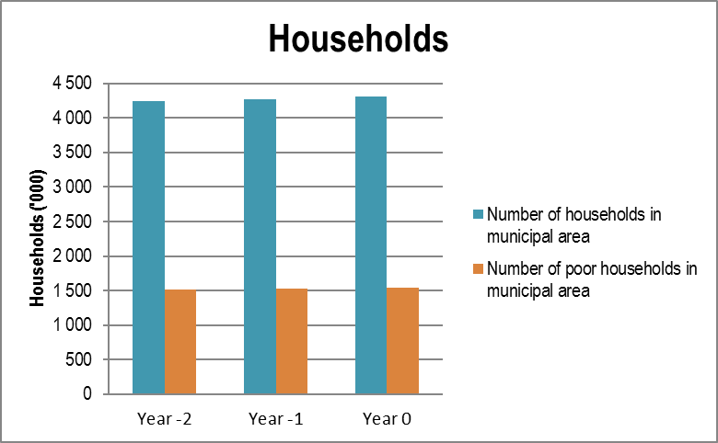

T1.2.3

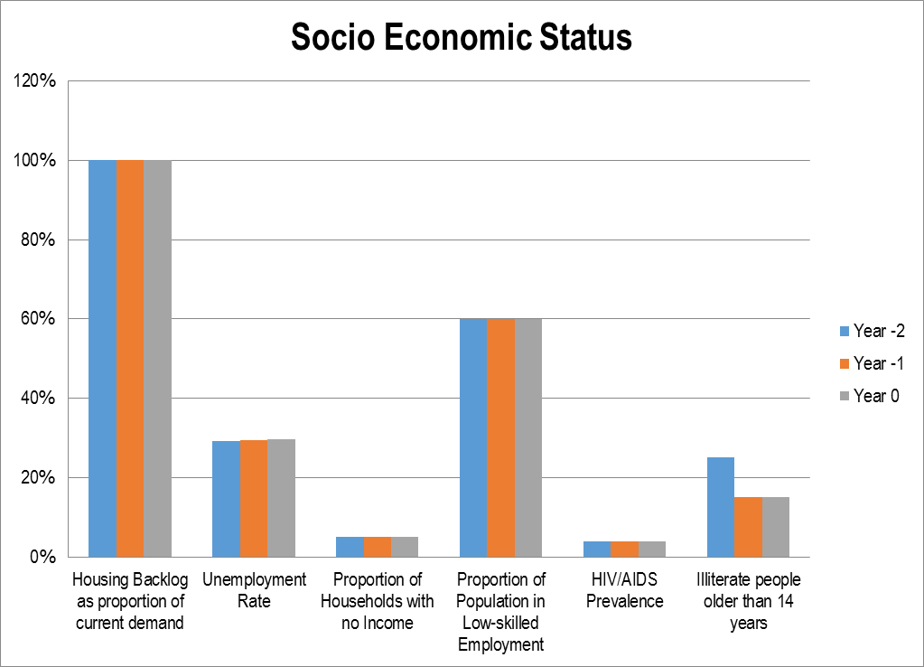

T 1.2.5

COMMENT ON BACKGROUND DATA:

The majority of the population of Thembelihle Local Municipality belong to the age group 10-19 with a total of 3 206 individuals followed by the 20-29 year olds with a total of 2 748, while the minority of the population belong to the age group 70+ sitting at 687 individuals. Approximately 1 538 households in the Municipal area are poor. The unemployment rate of the area is sitting at 29.58% which has significantly increased when compared to the 28.4% of 2001. With that said this necessitates that the Municipality offers support to these households. Thembelihle Local Municipality adopted the Indigent Management Policy that seeks to facilitate the provision of basic Municipal services to these poor households.

T 1.2.8

SERVICE DELIVERY OVERVIEW

SERVICE DELIVERY INTRODUCTION
Chapter three (3) of this report contains detailed service delivery reporting for the municipality.

The municipality is experiencing a backlog in terms of the provision of basic services. The formal performance reporting in the municipality is based on the targets set in the approved IDP and SDBIP.

a) Hopetown

The existing internal water pipes burst on a frequent basis and have to be replaced with PVC pipes. The capacity of the reservoirs is currently upgrade for approximately 10-year growth in development.

* The present sewer system (oxidation ponds) works at maximum capacity and needs to be replaced with a conventional system or upgraded. Provision has to be made for except able sewerage systems to address the needs of the informal residents with no sewerage services. A project is currently running to accommodate the upgrading of the ponds.
* The roads and storm water system is in a bad state with special reference to Steynville with no infrastructure due to the flat gradient. A storm water plan has been provided and the implementation thereof is essential. The steepness of the environment in all cases in Hopetown creates tremendous problems. The stormwater is not up to standard and causes tarred road maintenance to be very high.
* The electrical system is totally outdated and does not comply with basic professional safety regulations. The facilities at the main receipt sub-station are busy to be upgraded for future development.
* The closing of the present dumping site should be implemented as the site is next to the N12 and is a sore eye for any tourist or probable investor. The old site should be closed as soon as possible and a new one opened in the area identified by DWAF. Construction of the new solid waste site is completed, but the electricity switch is outstanding and need to be Licensed

b) Strydenburg

* The main water supply for the town and townships comes from the Witpoort boreholes system. The lifespan of this system remains is still uncertain. Therefore, the direct extraction of water out of the Orange River remains the only solution for this problem. This issue has been broad under the intention of DWAF. Possible plans are outline for this year to extract the water to Strydenburg.
* The old oxidation pond system needs to be rehabilitated since the New ponds was successfully completed and is already in use. The eradication of the bucket system in Deetlefsville and replacement with the VIP system causes unhappiness in the community more especially because housing development in the area make use of Water Bourne System.
* The roads and storm water system in Deetlefsville are in a very bad state and need to be upgraded over a period of time. The main road in Strydenburg needs to be resealed and the gravel streets have to be resurfaced to make them acceptable.
* Once again like in the case of Hopetown the main electrical system needs to be attended to. Some areas have been upgraded but the overall system is still dilapidated and old fashioned.

* The overhead connections are according to standard not acceptable anymore and have to be changed to underground connections. Even though it is expensive it is cost saving in the long run.

c) Other areas

The municipality will now provide services to surrounding farms as a responsibility. Research into the needs of the rural residents has to be done.
The future provision and maintenance of internal and bulk services would be addressed with reference to:
* water;
* roads;
* sewer;
* electricity;
* storm water; and
* refuse removal

T 1.3.1

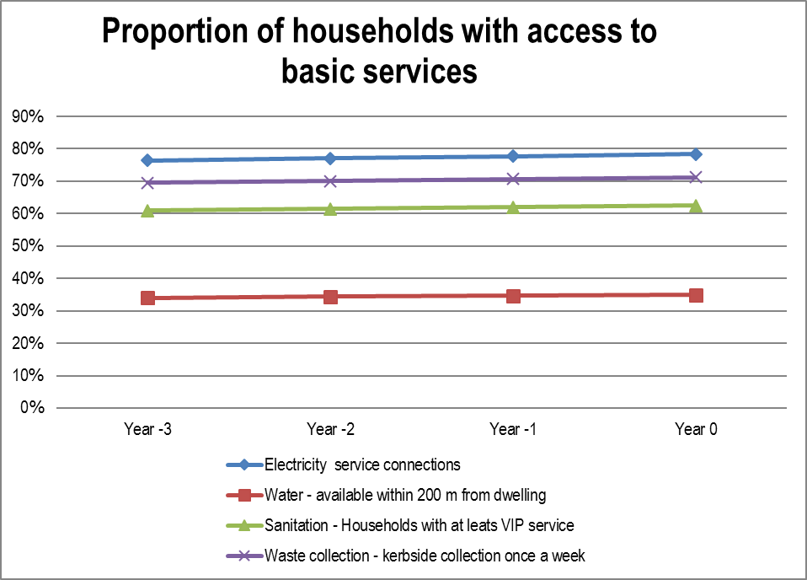

T 1.3.2

COMMENT ON ACCESS TO BASIC SERVICES:

Electricity

Previously, we were not able to provide alternative energy resources like paraffin and candles to those indigent families who do not receive FBS electricity because the updated register is indigent register is not up to date. We are sitting at 78% of households which have electricity service connections in the municipality.

Water

We are working diligently to provide basic services to as many households as possible. Currently there are a number of households which do not have access to water in their yard. Of these, 35% of them have street water taps available within 200m from any household.

Sanitation

VIP sanitation systems in Steynville (Hopetown) and Deetlefsville (Strydenburg) have not been received well by the residents of those areas with the major contributing factor thereto being that neighbouring suburbs are connected to water-borne sanitation. Services to areas like 7de Laan in Steynville and Deetlefsville in Strydenburg are planned through the housing department.

Waste collection

Thembelihle Local Municipality continues to provide waste collection services once a week to all households in Hopetown and Strydenburg. Unfortunately, residents have been dumping their waste illegally through the municipality. As a result, the municipality is struggling to cope with cleaning these illegal dumping sites because of our aging earth moving equipment which has failed us before. In the coming year, we plan to procure 4 bakkies and two cars for the functional operation of the Municipality. One tractor, a front loader and trailer for refuse removal.

Roads and storm water

The roads and storm water system is in a bad state with special reference to Steynville with no infrastructure due to the flat gradient. A storm water plan has been provided and the implementation thereof is essential. The steepness of the environment in all cases in Hopetown creates tremendous problems. The stormwater is not up to standard and causes tarred road maintenance to be very high.

T 1.3.3

FINANCIAL HEALTH OVERVIEW

FINANCIAL OVERVIEW

2015/16 was a very challenging year for the municipality given the financial constraints that the municipality was facing. External factors also played a role in the difficult times of the municipality and those of the rest of the country.

Thembelihle Local Municipality achieved R 41 894 million total revenue from exchange transactions against a budgeted R 56 658 million (original budget) and R62 103 million (adjusted budget) excludinig government grants and subsidies while R89 107 million was expended compared to R78 407 million in the adjustment budget.

The table below indicates the Municipality’s financial overview for the financial year.
T 1.4.1

COMMENT ON OPERATING RATIOS:

1. Employee Costs-ratio is 92%

Increased costs due to the appointment of a CFO; appointment of additional staff in the Electricity Department.

2. Repairs and maintenance-ratio is 2%

New infrastructure i.r.o water and electricity resulted in a decrease in repairs and maintenance costs.

3. Finance charges and impairment-ratio is 50 %

3.1 Increased costs due to cash flow problems resulted in creditors not being paid within the 30-day period which, in turn, added interest to be paid to the original capital amount.

3.2 Escalating non-payment by debtors resulted in an increase of bad debts written off.

T 1.4.3

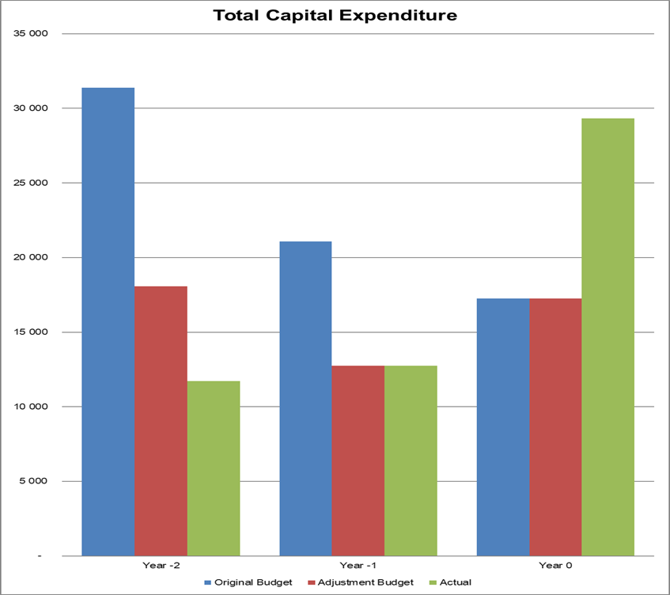
T 1.4.5

COMMENT ON CAPITAL EXPENDITURE:

For the 2015/2016 Financial Year, the original capital budget was R17 257 million, the adjustment budget remained unchanged from the original budget. The expenditure for the year amounted to R29 335 million.

As alluded to in the previous financial year, capital expenditure increased as projects were expedited which were funded from the RBI Grant from DWAF resulting in greater spending on the capital projects. Important water infrastructure projects are funded over multiple years.

T 1.4.5.1

ORGANISATIONAL DEVELOPMENT OVERVIEW

ORGANISATIONAL DEVELOPMENT PERFORMANCE

The biggest challenge that the municipality has faced throughout the years is with the attraction and retention of the skill of senior management or S57 which are managers directly accountable to the municipal manager. By the end of the financial year, there were a number of vacancies in senior management after the resignation of the Chief Financial Officer. The filling of vacancies is a top priority for the municipality.
T 1.5.1

AUDITOR GENERAL REPORT

AUDITOR GENERAL REPORT: YEAR 2015/16

The Auditor general issued a qualified audit opinion for the 2015/16 financial year which is the same audit opinion received in the 2014/15 financial year. An Audit Action plan has subsequently been developed which will be implemented during the 2016/17 financial year to address the issues raised by the Auditor General. The audit opinion was issued with matters of emphasis as outlined in the report of the Auditor General of South Africa included in the annual report in chapter 6.

There can be 5 different outcomes to an audit once the municipality has submitted their financial statements to the Auditor-General, which can be simply defined as follows:

Ø A clean audit: The financial statements are free from material misstatements and there are no material findings on reporting on predetermined objectives or non-compliance with legislation.
Ø Unqualified audit with findings: The financial statements contain material misstatements. Unless a clean audit outcome is expressed, findings will be raised on either reporting on predetermined objectives or noncompliance with legislation, or both these aspects.
Ø Qualified audit opinion: The financial statements contain material misstatements in specific amounts, or there is insufficient evidence to conclude that specific amounts included in the financial statements are not materially misstated.
Ø Adverse audit opinion: The financial statements contain material misstatements that are not confined to specific amounts, or the misstatements represent a substantial portion of the financial statements.
Ø Disclaimer of audit opinion: Insufficient evidence was provided in the form of documentation on which to base an audit opinion. The lack of sufficient evidence is not confined to specific amounts, or represents a substantial portion of the information contained in the financial statements.

T 1.6.1

STATUTORY ANNUAL REPORT PROCESS

No. | Activity | Timeframe
1 | Consideration of next financial year’s Budget and IDP process plan. Except for the legislative content, the process plan should confirm in-year reporting formats to ensure that reporting and monitoring feeds seamlessly into the Annual Report process at the end of the Budget/IDP implementation period | July
2 | Implementation and monitoring of approved Budget and IDP commences (In-year financial reporting). | July
3 | Finalise the 4th quarter Report for previous financial year | July
4 | Submit draft year 0 Annual Report to Internal Audit and Auditor-General | July
5 | Municipal entities submit draft annual reports to MM | July
6 | Audit/Performance committee considers draft Annual Report of municipality and entities (where relevant) | August
8 | Mayor tables the unaudited Annual Report | August
9 | Municipality submits draft Annual Report including consolidated annual financial statements and performance report to Auditor General | August
10 | Annual Performance Report as submitted to Auditor General to be provided as input to the IDP Analysis Phase | August
11 | Auditor General audits Annual Report including consolidated Annual Financial Statements and Performance data | September - October
12 | Municipalities receive and start to address the Auditor General’s comments | November
13 | Mayor tables Annual Report and audited Financial Statements to Council complete with the Auditor- General’s Report | November
14 | Audited Annual Report is made public and representation is invited | November
15 | Oversight Committee assesses Annual Report | November
16 | Council adopts Oversight report | December
17 | Oversight report is made public | December
18 | Oversight report is submitted to relevant provincial councils | December
19 | Commencement of draft Budget/ IDP finalisation for next financial year. Annual Report and Oversight Reports to be used as input | January
T 1.7.1

COMMENT ON THE ANNUAL REPORT PROCESS:

The 2015/16 Annual Report was compiled in accordance with the requirements of Section 121 of the Municipal Finance Management Act 56 of 2003 and Section 46 Municipal System Act 32 of 2000. The purpose of this Report is:
- To provide feedback on activities of the Municipality;
- To provide a report on performance in service delivery and budget implementation for the financial year, and
- To promote accountability to the community for period 1 July 2015 to 30 June 2016.

This Annual Report has been developed according to the provision of Circular No.63 of the Municipal Finance Management Act which indicates that real transparency and accountability can only be achieved where there is a clear link between the strategic objectives agreed with the community, the IDP, the Budget, SDBIP, in year reports, Annual Financial Statements, Annual performance report and the Annual Report.

Alignment between the IDP Budget and Performance Management

Chapter 5 of the Municipal Systems Act provides for the adoption of the IDP which set out the objectives and development goals of the municipality. It is therefore imperative that municipal council approve the budget in order to fund what the IDP as the plan is set to achieve. Furthermore, the Executive Mayor needs to approve the SDBIP as per Section 53 of the MFMA as the monitoring tool for the implementation of IDP according the approved Budget. The municipality is liable to present quarterly reporting on SDBIP, In-year budget reports, and Mid-Year performance review reports to inform Budget adjustments. The annual performance report and annual financial statements also must be submitted to the Auditor General whereby the audit report will be issued and incorporated into the Annual Report.

The annual report is submitted to MPAC for oversight and simultaneously publicised for public comments after the Council has adopted the Oversight report by MPAC by Municipality must place the Annual Report on the website for transparency. This process will surely improve accountability by the executive to non-executive and would deal with issues raised by the Auditor General and act on the recommendations thereof.

This annual report seeks to provide a detailed record of the municipality’s performance according to the set objectives in the Strategic plan, implemented through the IDP Process and monitored in accordance with the legislated reports.

T 1.7.1.1

CHAPTER 2 – GOVERNANCE

INTRODUCTION TO GOVERNANCE

Governance is the process of decision-making and the process by which decisions are implemented. An analysis of governance focuses on the formal and informal actors involved in decision-making and implementing the decisions made and the formal and informal structures that have been set in place to arrive at and implement the decision. Governance in the public sector needs to take into account legal and constitutional accountability and responsibilities

Corporate governance looks at issues of transparency and accountability where the Municipality outlines its top risks, the supply chain management process as well as how the Municipality deals with fraud and corruption issues. Together these imperative aspects ensure that all processes of the Municipality are properly functioning and that communities have access to municipal services.

Municipalities in South Africa are governed by Municipal Councils. The Thembelihle Council is therefore the governing body of the Thembelihle Local Municipality and the custodian of its powers, duties and functions, both legislative and administrative. Essentially, the Council performs a legislative and executive role. The Constitution of the Republic of South Africa, 1996, Chapter 7, Section 160 (1) defines the role of the Council as being:
* Making decisions concerning the exercise of all the powers and the performance of all the functions of the municipality;
* Electing its chairperson;
* Electing an executive committee and other committees, subject to national legislation; and
* Employing personnel that are necessary for the effective performance of its functions.

Thembelihle Local Municipality was established in terms of a Section 12 Notice of the Municipal Structures Act of 1998, the Municipality is a Category B Municipality which operates within the Mayoral Executive System combined with the Participatory Ward System. Governance at the municipality is composed of both the Political and Administrative Governance which ensures that governance involves the community and that all citizens within the Municipal Area are represented in decision making. The Political leadership of the Municipality exercise their executive and legislative powers and functions to govern the affairs of the Municipality. Administration is responsible for Corporate Governance as prescribed by various legislative frameworks.
T 2.0.1

COMPONENT A: POLITICAL AND ADMINISTRATIVE GOVERNANCE

INTRODUCTION TO POLITICAL AND ADMINISTRATIVE GOVERNANCE

Municipal Council comprises the governing and decision making body of the Municipality whilst municipal officials and staff focus on implementation. Council determines the direction for the municipality by setting the course and allocating the necessary resources. Council establishes the policies, and municipal staff ensures that those policies are implemented. Decisions made at Council or committee level are often the result of a lot of research, consultation and advice from staff, residents, business people, and interested parties. Often there are competing interests and financial constraints that must be considered.
T 2.1.0

POLITICAL GOVERNANCE

INTRODUCTION TO POLITICAL GOVERNANCE

Thembelihle Local Municipality is governed by a council led by an Executive Mayor. All major policy and administrative decisions are presented, resolved and implemented after the approval of Council. The political system in the municipality is functioning fairly well. There is a Municipal Public Accounts Committee (MPAC) whose mandate is to interrogate municipal performance and thus assist the municipality to act in the manner that assist service delivery. The annual report is publicized for scrutiny and comment of the public as well.
T 2.1.1

 | POLITICAL STRUCTURE  MAYOR  DA Jonas
 | OTHER COUNCILLORS  Councillor SE Madikane  Councillor B Mpamba  Councillor E De Bruin  Councillor P Louw (Deceased)  Councillor A Kywe  Councillor MA Humphreys  Councillor H Gosa (Appointed to replace Cllr. P Louw) |  | T 2.1.1

COUNCILLORS

For the year ended 30 June 2016, the municipality had a total of 7 councilors with one permanent councilor serving as Mayor and Speaker simultaneously.

Four of these are ward councilors, three from the African National Congress and one ward councilor who is Independent. Three of the proportional councilors are from the Congress of the People and one from the Democratic Alliance.

During the year, we were met with the sad news of the untimely passing of one of our councilors, Councilor P Louw. As a municipality, our sincere condolences go out to Councilor P Louw family and loved ones.

Also refer to Appendix A where a full list of Councilors can be found (including committee allocations and attendance at council meetings).

Also refer to Appendix B which sets out committees and committee purposes.

T 2.1.2

POLITICAL DECISION-TAKING

Political decision-taking happens by way of council resolutions.

Council ensures that the mandate of local government to local communities is observed.

T 2.1.3

2.2 ADMINISTRATIVE GOVERNANCE

INTRODUCTION TO ADMINISTRATIVE GOVERNANCE

The Municipal Manager is the Accounting Officer. The Municipal Manager advises the Council and its committees on administrative matters such as policy issues, financial matters, organizational requirements and personnel matters. The Municipal Manager has to personally provide reasons to Council for the way in which the financial affairs of the departments of Council had been conducted, and this will be conducted with the assistance of the Finance Department.

The day-to-day management of the Municipality is done by staff under the direction of the Municipal Manager and Heads of Departments. The Municipal Manager and Heads of Departments have broad and general management responsibilities, such as making sure staff is kept abreast on Council’s direction, and identifying gaps in service delivery. Together with Council they must monitor progress on set goals and priorities.

T 2.2.1

Photo   | TOP ADMINISTRATIVE STRUCTURE  MUNICIPAL MANAGER  Abraham Mpho Mogale | Function  Overall General Management  Strategic Support Services  Infrastructure Services  Social Services  Financial Management  Corporate Support Services  Political Support Services  IDP
 | Chief Financial Officer  (as at 30 June 2016)  Bonga Sithole  Chief Financial Officer (Previous)  Mr. JG Butterworth (01 Jul 2015 – 31 Mar 2016)  MANAGER: CORPORATE SERVICES  Mr. E Mguye  MANAGER: TECHNICAL SERVICES  Mr. S Marufu |  | Budget and Treasury Manager  Creditors  Expenditure  Revenue  Supply Chain Management  Valuations  Corporate Administration  Human Resources  Marketing, Communications  and Customer Relations  Management  ICT Services  Water and Sanitation  Roads and Storm water  Electricity  Building Maintenance
 |  | T2.2.2

COMPONENT B: INTERGOVERNMENTAL RELATIONS

INTRODUCTION TO CO-OPERATIVE GOVERNANCE AND INTERGOVERNMENTAL RELATIONS

Active participants in the District Technical IGR and District IGR.

Full interaction with provincial sector departments.

T 2.3.0

2.3 INTERGOVERNMENTAL RELATIONS

NATIONAL INTERGOVERNMENTAL STRUCTURES

The municipality does not participate in any national intergovernmental structure(s).

T 2.3.1

PROVINCIAL INTERGOVERNMENTAL STRUCTURE

The municipality does not participate in any provincial intergovernmental structure(s).

T 2.3.2

RELATIONSHIPS WITH MUNICIPAL ENTITITIES

The municipality does not have any municipal entities.

T 2.3.3

DISTRICT INTERGOVERNMENTAL STRUCTURES

Active participants. Have service level agreement in place on housing delivery.

T 2.3.4

COMPONENT C: PUBLIC ACCOUNTABILITY AND PARTICIPATION

OVERVIEW OF PUBLIC ACCOUNTABILITY AND PARTICIPATION

Section 16 of the MSA refers specifically to the development of a culture of community participation within municipalities. It states that a municipality must develop a culture of municipal governance that complements formal representative government with a system of participatory governance. It must encourage and create conditions for the local community to participate in the affairs of the community. Such participation is required in terms of:

* the preparation, implementation and review of the IDP;
* establishment, implementation and review of the performance management system;
* monitoring and review of performance, including the outcomes and impact of such performance; and
* preparation of the municipal budget.

T 2.4.0

2.4 PUBLIC MEETINGS

COMMUNICATION, PARTICIPATION AND FORUMS

Notices are sent prior to the commencement date of the public meeting sessions. Pamphlets and posters are developed and disseminated across the municipal area aimed at reaching out to all the communities. The purpose of public meetings is to elicit input from the community on the compilation of the IDP.

T 2.4.1

WARD COMMITTEES

The municipality had 4 wards and only 3 ward committees of which 1 ward committee was functional during the year.

Refer to Appendix E which contains further details on ward committee governance and to Appendix F that contains performance data on a ward by ward basis.
T 2.4.2

COMMENT ON THE EFFECTIVENESS OF THE PUBLIC MEETINGS HELD:

Delete Directive note once comment is completed – Set out the key benefits for the municipality and the public from the above mentioned meetings.

T 2.4.3.1

2.5 IDP PARTICIPATION AND ALIGNMENT

COMPONENT D: CORPORATE GOVERNANCE

OVERVIEW OF CORPORATE GOVERNANCE

Governance is the process of decision-making and the process by which decisions are implemented. An analysis of governance focuses on the formal and informal actors involved in decision-making and implementing the decisions made and the formal and informal structures that have been set in place to arrive at and implement the decision. Governance in the public sector needs to take into account legal and constitutional accountability and responsibilities.

Thembelihle Local Municipality was established in terms of Section 12 Notice of the Municipal Structures Act of 1998. In terms of the Section 12 Notice, the Municipality is a Category B Municipality which operates within the Mayoral Executive System combined with the Participatory Ward System. Governance at the municipality is composed of both the Political and Administrative Governance which ensures that governance involves the community and that all citizens within the Municipal Area are represented in decision making.

The Political leadership of the Municipality exercise their executive and legislative powers and functions to govern the affairs of the Municipality. Administration is responsible for Corporate Governance as prescribed by various legislative frameworks. Corporate governance looks at issues of transparency and accountability where the Municipality outlines its top risks, the supply chain management process as well as how the Municipality deals with fraud and corruption Issues. Together these imperative aspects ensure that all processes of the Municipality are properly functioning and that communities receive quality services.

T 2.6.0

2.6 RISK MANAGEMENT

RISK MANAGEMENT

Enterprise Risk Management (ERM) forms a critical part of any entity’s strategic management. It is the process whereby an entity both methodically and intuitively addresses the risk attached to their activities with the goal of achieving a sustained benefit within each activity and across a portfolio of activities. Enterprise Risk Management is therefore recognized as a strategic, integral part of sound organizational management and is being promoted internationally and in South Africa as good business practice applicable to the public and private sectors.

All entities face uncertainty and the challenge for management is to determine how much uncertainty to accept as it strives to grow stakeholder value. Uncertainty presents both risk and opportunity, with the potential to erode or enhance value.

Enterprise risk management enables management to effectively deal with uncertainty and associated risk and opportunity, enhancing the capacity to build value. Value is maximized when management sets strategy and objectives to strike an optimal balance between growth and return goals and related risks, and efficiently and effectively deploys resources in pursuit of the entity’s objectives.

The following factors require consideration when integrating ERM into organizational decision-making structures:

* Strategically aligning risk management with objectives at all levels of the organization
* Introducing risk management components into existing strategic planning and operational practices
* Including risk management as part of employees’ performance appraisals; and
* Continuously improving control and accountability systems and processes to take into account risk management and its results.

The Enterprise Risk Management Framework specifically addresses the structures, processes and standards implemented to manage risks on an enterprise-wide basis in a consistent manner. The standards further address the specific responsibilities and accountabilities for the ERM process and the reporting of risks and incidences at various levels within the municipality.

The top 5 risks that the municipality is facing with regard to service delivery are as follows:
* No standby generators for total breakdown of electricity supply.
* Roads are in poor conditions as a result of poor service delivery.
* No proper machinery available for the maintenance of roads
* No vehicles available for the removal of refuse
* Land fill sites might not be properly maintained

T 2.6.1

2.7 ANTI-CORRUPTION AND FRAUD

FRAUD AND ANTI-CORRUPTION STRATEGY

Municipality has no risk management and associated actions policies in place but the matter is being attended to. We do not have a fraud hotline.

A risk assessment was previously done for the municipality.

There is no Audit Committee in place and the function is not being performed. Plans underway to establish an Audit Committee in the 2016/2017 financial year.

Internal audit is also done by shared services from district municipality and functioning very well.

T 2.7.1

2.8 SUPPLY CHAIN MANAGEMENT

OVERVIEW SUPPLY CHAIN MANAGEMENT

The municipality’s Supply Chain Management Policy was adopted by council on 29 May 2015.

The municipality’s SCM policy is fairly good in that it was developed in compliance with Municipal SCM Regulations as issued by National Treasury. The different committees established, pursuant to the Supply Chain Management Policy, are fully functional.

Council has also adopted a policy on irregular, unauthorized and wasteful expenditure on 29 May 2015. The policy is aimed at providing the accounting officer with an overview of legislation pertaining
to unauthorized, irregular, fruitless and wasteful expenditure and the recovery of same where
applicable.

T 2.8.1

2.9 BY-LAWS

COMMENT ON BY-LAWS:

Only the Municipal Property Rates By-Law was developed, approved and adopted by council and gazetted during 2015/6.

T 2.9.1.1

2.10 WEBSITES

COMMENT MUNICIPAL WEBSITE CONTENT AND ACCESS:

The municipal website www.thembelihlemunicipality.gov.za came on line during July 2013 and is an integral part of a municipality's communication infrastructure and strategy. It serves as a tool for community participation, improves stakeholder involvement and facilitates stakeholder monitoring and evaluation of municipal performance. Section 75 of the MFMA requires that the municipalities place key documents and information on their website, including the IDP, the annual budget, adjustments budgets and budget related documents and policies.

The municipality acknowledges that not all documents as prescribed by Section 75 of the MFMA were placed on the website. In the financial year 2016/2017, the MFMA guidelines will be used as a checklist to ensure that the Municipality complies by sending relevant departments requests for the information as prescribed by the Act.

T 2.10.1.1

2.11 PUBLIC SATISFACTION ON MUNICIPAL SERVICES

PUBLIC SATISFCATION LEVELS

No public satisfaction surveys on municipal services were conducted during 2015/16.

T 2.11.1

Concerning T 2.11.2:

No public satisfaction surveys on municipal services were conducted during 2015/16.
T 2.11.2.1

COMMENT ON SATISFACTION LEVELS:

No public satisfaction surveys on municipal services were conducted during 2015/16.

T 2.11.2.2

CHAPTER 3 – SERVICE DELIVERY PERFORMANCE (PERFORMANCE REPORT PART I)

INTRODUCTION
The key focus in Thembelihle Local Municipality has been to ensure that bulk services are in place to meet the demands of all residents and commercial endeavors. We can report the following achievements:

Water

Upgrading on the pump station in Stydenburg has been completed and is in retention now as they monitor the project to ensure its fully working capacity.
Linked to the pump station is the additional boreholes with switchgears in Strydenburg which assist in the getting of water which will be used for clean drinking water in the community
Water reticulations were also installed in the ongoing Hou Jou Bek area

Electricity

The municipality benefitted heavily from Eskom programme in which houses which have had no electricity have now been connected to the electricity grid.
310 housing units in Hopetown have been electrified.
112 housing units in Strydenburg have been electrified

Sanitation

The business plan under the MISA eradication of bucket toilets project was approved in Dec 2013. Construction began in March 2014 and is still in progress. The area chosen for the installation of water and sanitation services were two blocks (56 erven) in Houjoubek in Steynville. The project involves the installation of a water network and waterborne sewerage to these erven.

Roads and Storm water drainage

New roads were built in Deetlefsville in ward 1 which is going to be a significant help in the transport industry. Roads were upgraded in Steynville which will ensure visitors and residents have comfortable and safe journey when entering Hopetown.

Solid Waste Removal

Generally, the backlogs to services in indigent areas remains on a slow pace due to municipality’s financial situation but services are being delivered even at a slower than expected pace.

T 3.0.1

COMPONENT A: BASIC SERVICES

This component includes: water; waste water (sanitation); electricity; waste management; and housing services; and a summary of free basic services.

INTRODUCTION TO BASIC SERVICES
Thembelihle Local Municipality is committed to service delivery, especially to our poor community members. Access to employment, improvement of services like water, sanitation, refuse collection and safe roads and effective storm water drainage systems are all part of improving the lives of all in our municipal area

Biggest project was water based as this part of the country is prone to droughts and a manner in which to tackle water shortages was building new water abstraction points as well as new boreholes in which clean drinking water will be for the community at large.

Large number of houses are supplied electricity through Eskom. As well as new water supply methods with the water abstractions points having been completed and ready to serve the community at large.

T 3.1.0

3.1. WATER PROVISION

INTRODUCTION TO WATER PROVISION

Water for Hopetown and Steynville is obtained from the Orange River. It is purified at the New Water Treatment Works which is based on conventional water treatment processes. In other regions within the municipality boreholes are also a major part of water collection with them being used mainly for clean drinking water.

One of the biggest issues is installing meters in the various farms which gather water from the Orange River where the Municipality can better monitor their usage which is now in planning and implementation stage from Technical Services.

In order the increase capacity of water supply in the municipality the upgrading of the water station in Strydenberg including two additional boreholes was completed and are currently in retention.

Blue Drop information is currently unavailable. In any case Thembelihle has always had an excellent blue drop status in Hopetown and Strydenberg as seen in 2012 assessment done by AAS Solutions and Orange Free State Laboratory.

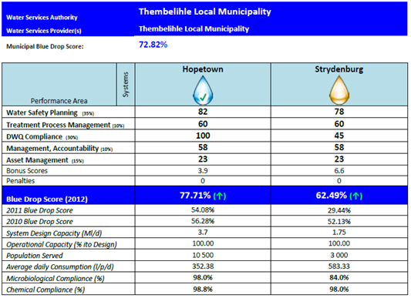

T 3.1.1

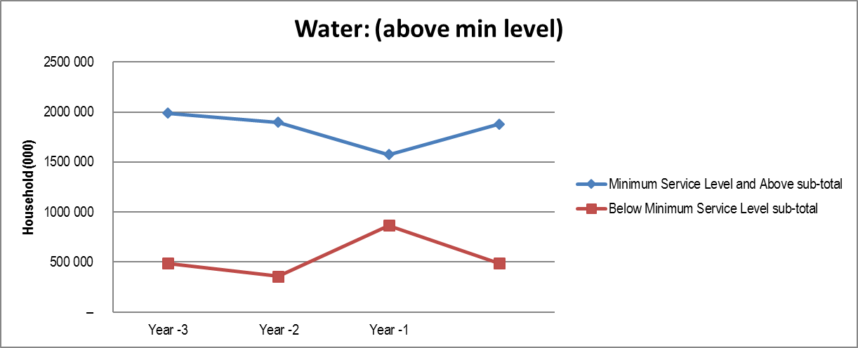

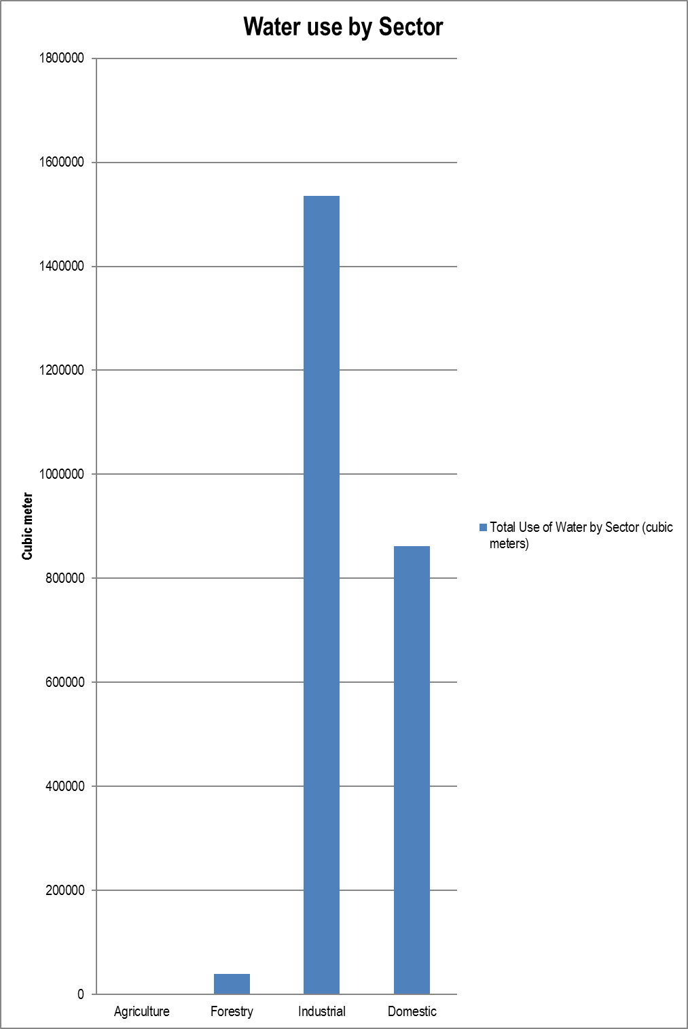
T 3.1.2.1

COMMENT ON WATER USE BY SECTOR:

Due to the newly upgraded stations and reform in the water section, water consumption data is inadequate but the municipality is in the process of installing meter readings at farms and so forth where it can give a better data collection of the consumption of water in the municipality.

There has been a sharp increase in water loses over the year which is unacceptable which resulted in a loss of over R 6 500 000 to the municipality.
T 3.1.2.2

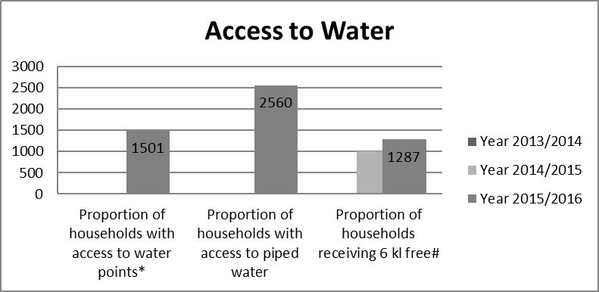

* Means access to 25 liters of potable water per day supplied within 200m of a household and with a minimum flow of 10 liters per minute
# 6,000 liters of potable water supplied per formal connection per month
T 3.1.5

COMMENT ON WATER SERVICES PERFORMANCE OVERALL:

In terms of the IDP, Water abstraction, upgrading if water network pipelines and additional boreholes in Strydenberg were the main priorities regarding water.

Replacing of the UPVC pipes could not be done as the municipality was experiencing some financial difficulties.

Upgrading of the Pump station in Strydenberg was completed during the year and is currently on retention. Various in the budget can be attributed to the various delays in construction varying from worker restlessness to rain delays.

Additional boreholes were also built which assisted the community with much needed water in the drought stricken year.

Number one priority was upgrading of the pump station which resulted in higher flow of water to the dam and reservoir which is going to benefit the community for a long time to come.

The vacancies in the water services is also problematic as it doesn’t aid in the speedily implementation of the targets set out during the year.

T 3.1.10

3.2 WASTE WATER (SANITATION) PROVISION

INTRODUCTION TO SANITATION PROVISION

Sanitation is still a problem in informal settlements in the Thembelihle municipality, and in already established sanitation areas, the water system needs to be upgraded to the new waterborne sewage system.

Thembelihle has not provided any new sanitation services during the 2015/2016year. This has been due to inadequate planning resulting in no business plans being developed to attract MIG or other funding.

As a result, none of the IDP targets were met which would have addressed this issue but in future we hope the financial situation improves so we can do the necessary projects to meet IDP targets.

T 3.2.1

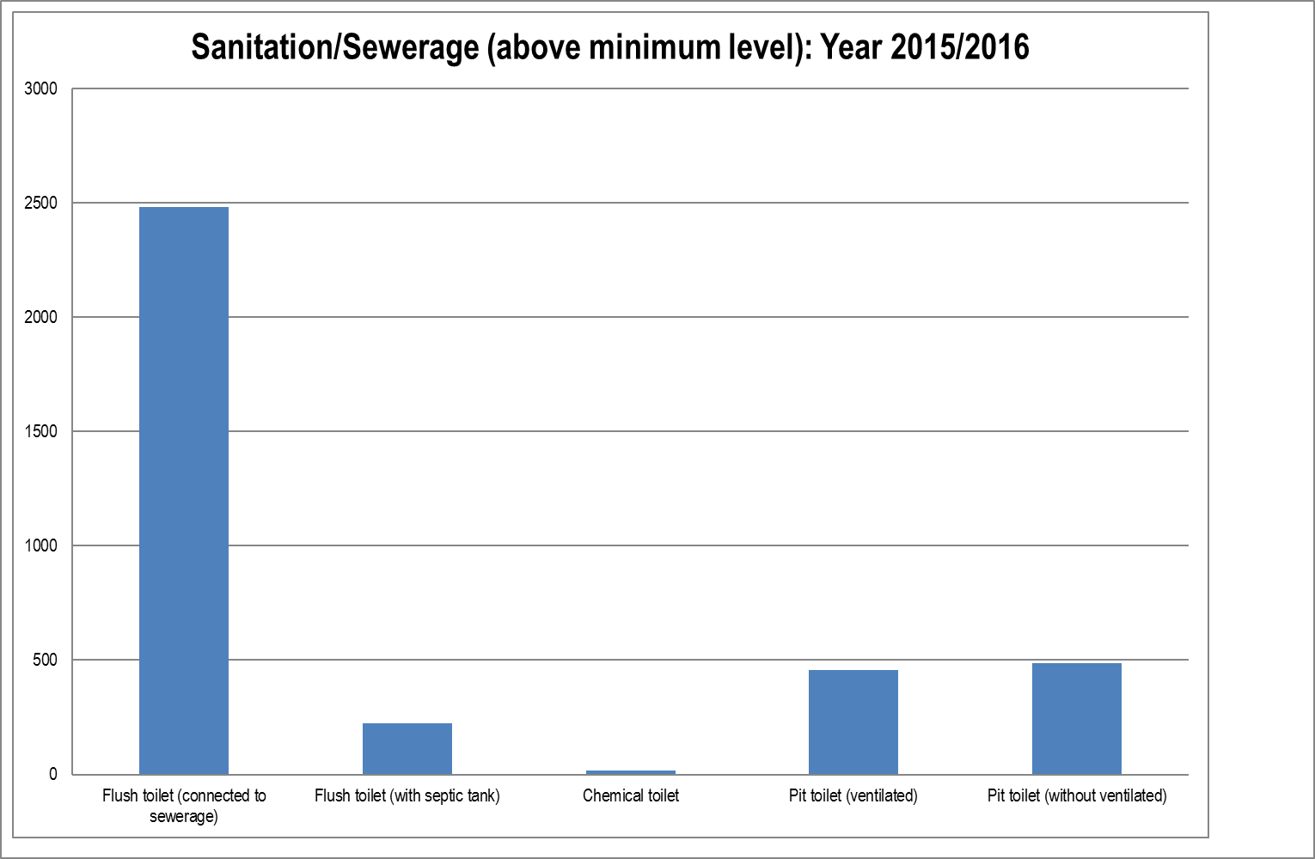

T 3.2.2

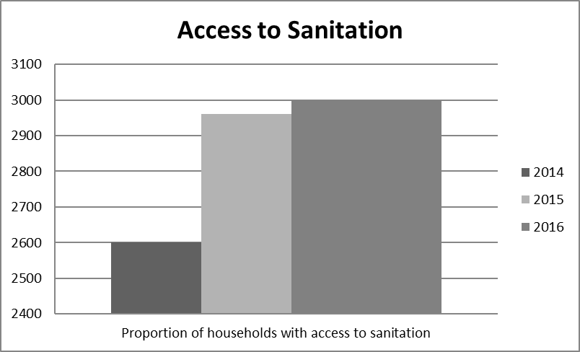

T 3.2.5

COMMENT ON SANITATION SERVICES PERFORMANCE OVERALL:

Sewerage network extention within the Thembelihle Municipal area is one of the big plans which are being conducted long term in the municipality. Sadly funding for these projects need to sourced but will emmensly increase the quality of life for all residents and visitors of Hopetown and Strydenberg.

T 3.2.10

ELECTRICITY

INTRODUCTION TO ELECTRICITY

Most of the electricity in municipality is supplied by the Municipality and the rest including new connections is done by ESKOM as a programme of theirs.

There is been an increase in prepaid meters as well as increase in those indigent households receiving the 50kw of electricity per month which did put some strain on the services rendered.

T 3.3.1

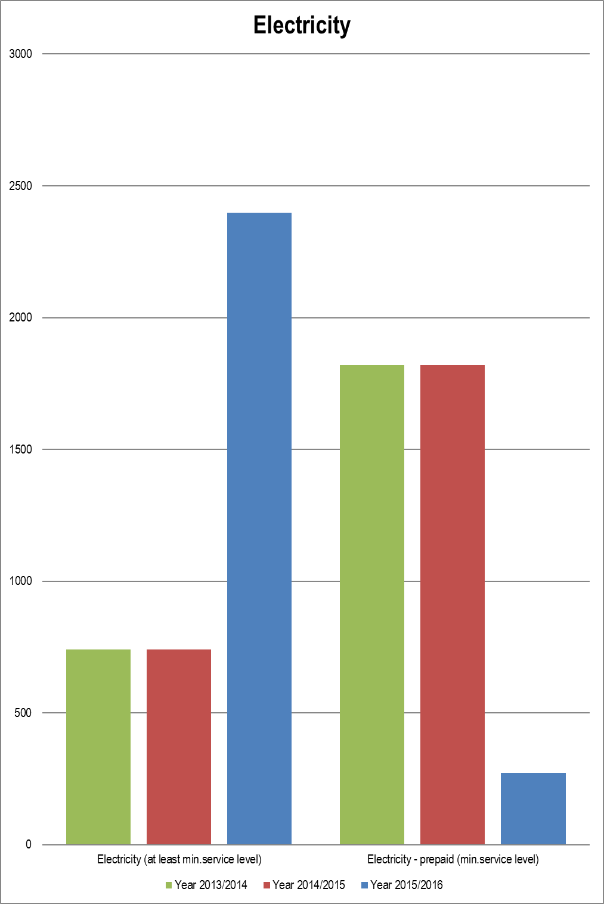
T 3.3.2

COMMENT ON ELECTRICITY SERVICES PERFORMANCE OVERALL:

Biggest issue is the non reading of meters in the municipality and non implimenting of measures to contain electricity loss which is at 43% which is weel above the standard of 10%.

Electrical Services needs more skilled personel in order to function as well as revised organigram to deal with the change in enviroment for a suitable working service.

ESKOM programme has been much help in helping to connect numerous home I the 2015/2016 year which should continue well into the next financial year.

The municipality needs to replace and repair the street lights in the identified areas of Hopetown as well as the location in order for it to meet service delivery targets.

T 3.3.9

3.4 WASTE MANAGEMENT (THIS SECTION TO INCLUDE: REFUSE COLLECTIONS, WASTE DISPOSAL, STREET CLEANING AND RECYCLING)

INTRODUCTION TO WASTE MANAGEMENT

Thembelihle Municipality still provides refuse services at least once a week to all residents of Hopetown and Strydenberg but a big problem making it costly in Steynville is that residences do not put the refuse in black bags but rather at the corner of the street which is a health hazard and also makes it difficult and costly to clean up the refuse effectively.

T 3.4.1

COMMENT ON WASTE MANGEMENT SERVICE PERFORMANCE OVERALL:

Waste Management needs to become a priority in Thembelihle because not only will is cause future health hazards making it uninhabitable by residents but it will also pollute the environment which is bad since the municipality is also trying to go green to combat it ecological footprint on the world.

Serious need to fill the vacancies within the service as this will assist greatly in delivering better quality of service to paying residences and indigents.
T 3.4.10

3.5 HOUSING

INTRODUCTION TO HOUSING
The provision of housing is being dealt with in collaboration with Pixley ka Seme District Municipality as well as Pixley ka Seme regional office of Department of Cooperative Governance, Human Settlements and Traditional Affairs.

Currently there are no projects to provide further housing to the community as there has been vacancies which make it difficult to go forward but applications for housing are being sent to Northern Cape Department of Co-operative Governance, Human Settlements and Traditional Affairs for further action on their part as funds become available.

T 3.5.1

COMMENT ON THE PERFORMANCE OF THE HOUSING SERVICE OVERALL:

Housing services are currently being stalled pending approval of new project to build houses in the upcoming years, and title deeds to existing houses already built is also in process but the process needs to speed up much quicker pace.

T 3.5.7

3.6 FREE BASIC SERVICES AND INDIGENT SUPPORT

INTRODUCTION TO FREE BASIC SERVICES AND INDIGENT SUPPORT

Thembelihle is committed to provide the following free basic services:
* 6 kl of potable water per month per household
* 50 kWh of electricity for registered indigents
* Free refuse removal for registered indigents
* Free sanitation for registered indigents

Households with less than R 3 500 income per month qualify for these services at no cost.

T 3.6.1

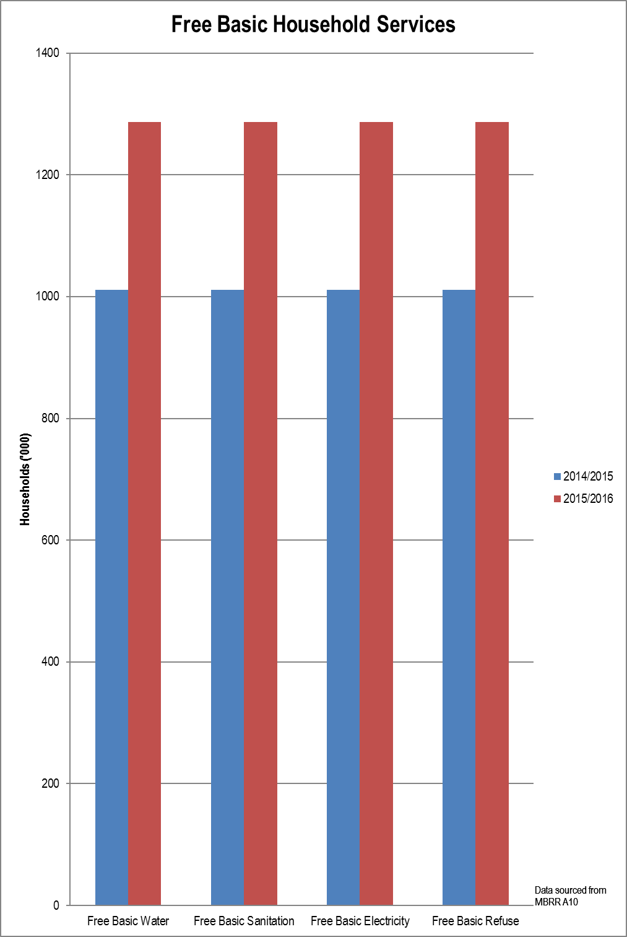
T 3.6.2

COMMENT ON FREE BASIC SERVICES AND INDIGENT SUPPORT:

Thembelihle Local Municipality needs to update its indigent register as a priority for planning purposes and funding resourcing.

T 3.6.6

COMPONENT B: ROAD TRANSPORT

This component includes: roads; transport; and waste water (stormwater drainage).

INTRODUCTION TO ROAD TRANSPORT

In terms of road transport, the municipality does not have any projects not budget for any in the past financial years.
T 3.7

3.7 ROADS

INTRODUCTION TO ROADS

Maintenance of internal roads by Provincial Department of Public Works is ongoing process which has seen the road quality within Thembelihle increase.

New roads were completed in Deetlyville, Steynville and Hopetown are under retention but it has also seen an ease in traffic as well as better comfort for not only residents but also visitors to the municipality.
T 3.7.1

No information available.
T 3.7.5

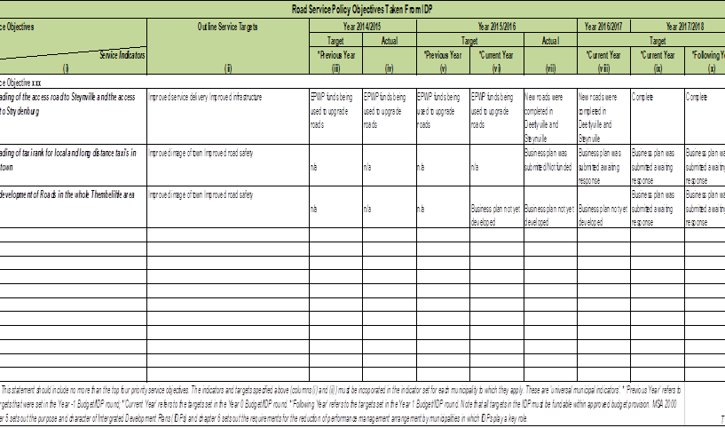

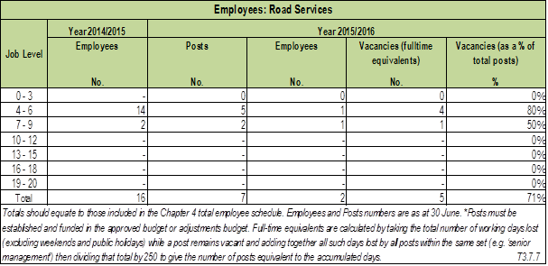

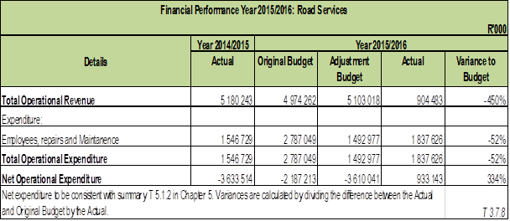

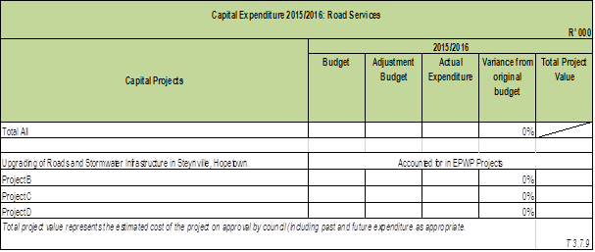

COMMENT ON THE PERFORMANCE OF ROADS OVERALL:

Thembelihle has done well with the little resources to upgrade roads in Deetlyville, Steynville and hopes to increase it to other areas in the coming future. More long term solutions would be for a Capital project which provides road services to deal with the backlogs and improve infrastructure.
T 3.7.10

3.8 TRANSPORT (INCLUDING VEHICLE LICENSING & PUBLIC BUS OPERATION)

INTRODUCTION TO TRANSPORT

No information available.
T 3.8.1

Concerning T 3.8.2

No data.
T 3.8.2.1

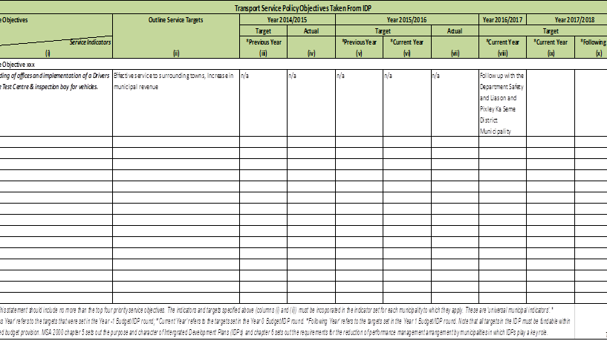

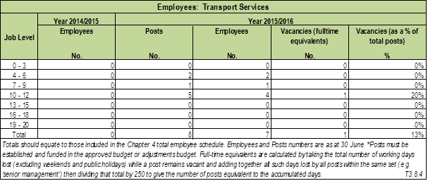

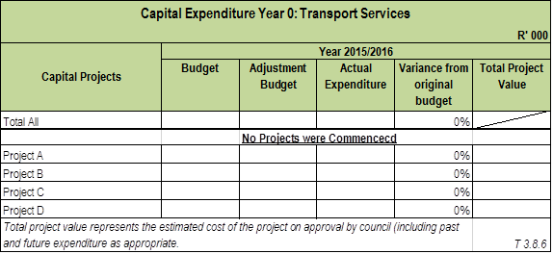

COMMENT ON THE PERFORMANCE OF TRANSPORT OVERALL:

Transport services needs serious attention especially regarding the traffic fines situation as they should be recognised on an accrual basis and not on a cash basis.

The municipality will be working hard in order to transform the transport division in the upcoming years with the help of Provincial and National Government.
T 3.8.7

3.9 WASTE WATER (STORMWATER DRAINAGE)

INTRODUCTION TO STORMWATER DRAINAGE

In Thembelihle, the stormwater drainage is dealt to gether with roads as when one builds a road there needs to be storm water infrastructure in order to make it viable.
Most of the land in Themeblihle is flat which makes drainage problems that leads major damage to roads as ponds are formed one of the big issues.

Costs related to storm water as afrorementioned are accounted for in Roads Services.

T 3.9.1

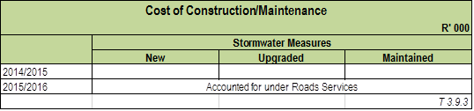

Accounted for under Roads section.
T 3.9.4

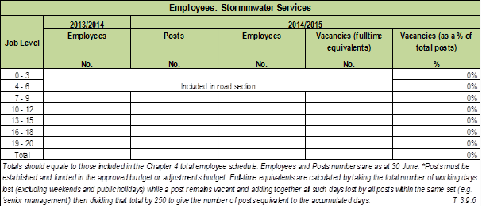

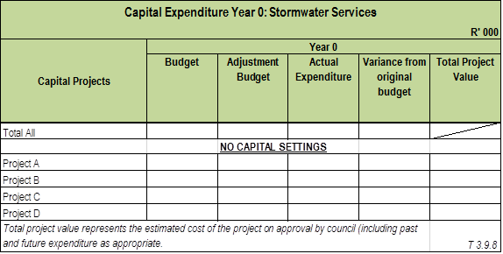

COMMENT ON THE PERFORMANCE OF STORMWATER DRAINAGE OVERALL:

Not applicable as it is dealt with in Roads Services in 3.7.10
T3.9.9

COMPONENT C: PLANNING AND DEVELOPMENT

This component includes: planning; and local economic development.

INTRODUCTION TO PLANNING AND DEVELOPMENT

The municipality is an hour’s drive from Kimberley which has been declared as a special economic zone which offers the opportunity to tap into the vast potential available.

The town of Hopetown is situated on the crossroads of the N12 and the route accessing the N10 at Hanover, where most of the urban development is situated within close proximity of these main routes.

The upgrading of the road to Douglas to a tarred road presents further future local economic development potential.

The banks of the Orange River also present enormous economic development potential, which could support emerging farmers.

T 3.10

3.10 PLANNING

INTRODUCTION TO PLANNING

The planning section needs to be strengthened drastically. The position of Manager: Planning and Development exist on the approved staff establishment and need to be filled in the 2016/2017 financial year.

All town planning activities are performed by external service providers with input from municipal officials and consultations with council. Building regulations is done through shared services rendered by Pixley Ka Seme District municipality
T 3.10.1

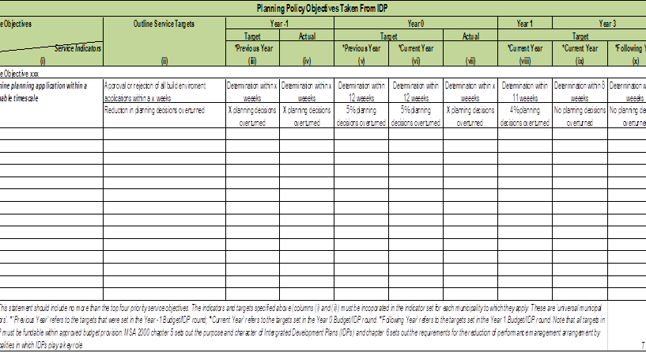

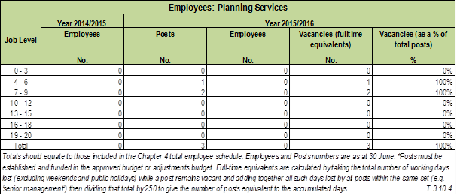

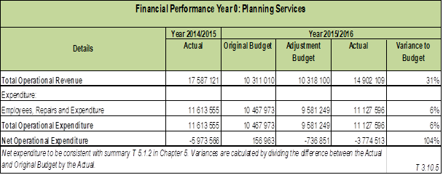

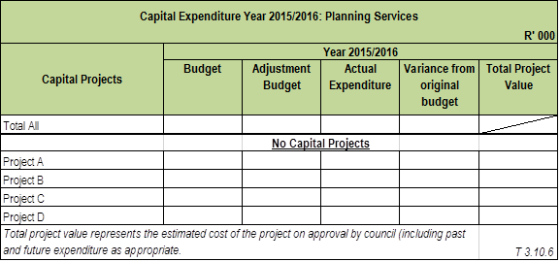

COMMENT ON THE PERFORMANCE OF PHYSICAL PLANNING OVERALL:

Planning Services has no staff at all which is very worrying and hence nothing has been done in the section so far which we hope is rectified in the upcoming year.
T 3.10.7

3.11 LOCAL ECONOMIC DEVELOPMENT (INCLUDING TOURISM AND MARKET PLACES)

INTRODUCTION TO ECONOMIC DEVLOPMENT

Economic development is aligned to the provincial and National plan of the country with regards to service delivery and other basic services.
T 3.11.1

COMMENT ON LOCAL JOB OPPORTUNITIES:

There has been no information on number of employment created by each sector within the Municipality in the 2015/2016 year

T 3.11.4

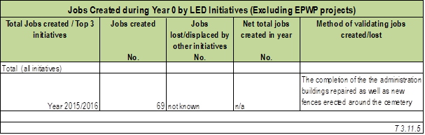

COMMENT ON LOCAL ECONOMIC DEVELOPMENT PERFORMANCE OVERALL:

Job creation decrease unemployment and up lift the community. The cemetery in Strydenburg was fenced and cleaned. Potholes in Hopetown were repaired and the cemetery was cleaned. Both towns were cleaned. Good project but more needs to be done to stop the delays in implementation of the projects in order to create jobs
T 3.11.11

COMPONENT D: COMMUNITY & SOCIAL SERVICES

This component includes: libraries and archives; museums arts and galleries; community halls; cemeteries and crematoria; child care; aged care; social programmes, theatres.

INTRODUCTION TO COMMUNITY AND SOCIAL SERVICES

Three libraries service the residents of Thembelihle Municipality as well as two community halls and four cemeteries.
T 3.52

3.12 LIBRARIES; ARCHIEVES; MUSEUMS; GALLERIES; COMMUNITY FACILITIES; OTHER (THEATRES, ZOOS, ETC)

INTRODUCTION TO LIBRARIES; ARCHIEVES; MUSEUMS; GALLERIES; COMMUNITY FACILITIES

Library services are open to the public and charge a small fee in order to lend books, where Schools pay a much reduced fee for learners to use the library.

T3.12.1

SERVICE STATISTICS FOR LIBRARIES; ARCHIVES; MUSEUMS; GALLERIES; COMMUNITY FACILITIES; OTHER (THEATRES, ZOOS, ETC)

No information available.
T 3.12.2

COMMENT ON THE PERFORMANCE OF LIBRARIES; ARCHIVES; MUSEUMS; GALLERIES; COMMUNITY FACILITIES; OTHER (THEATRES, ZOOS, ETC) OVERALL:

Libraries have many books which is always a good thing for an education driven country as South Africa is in Africa, it is also well supported by Department Arts and Culture and properly manned. Different programs as contained in the business plan are run.
The Library service can only go from strength to strength.
T 3.12.7

3.13 CEMETORIES AND CREMATORIUMS

INTRODUCTION TO CEMETORIES & CREMATORIUMS

No information available.
T 3.13.1

SERVICE STATISTICS FOR CEMETORIES & CREMATORIUMS

No information available.
T 3.13.2

COMMENT ON THE PERFORMANCE OF CEMETORIES & CREMATORIUMS OVERALL:

No information available.
T 3.13.7

3.14 CHILD CARE; AGED CARE; SOCIAL PROGRAMMES

INTRODUCTION TO CHILD CARE; AGED CARE; SOCIAL PROGRAMMES

Non information available.
T 3.14.1

SERVICE STATISTICS FOR CHILD CARE

No information available.

T 3.14.2

COMMENT ON THE PERFORMANCE OF CHILD CARE; AGED CARE; SOCIAL PROGRAMMES OVERALL:

No information available.
T 3.14.7

COMPONENT E: ENVIRONMENTAL PROTECTION

This component includes: pollution control; biodiversity and landscape; and costal protection.

INTRODUCTION TO ENVIRONMENTAL PROTECTION

No information available.

T 3.14

3.15 POLLUTION CONTROL

INTRODUCTION TO POLLUTION CONTROL

No information available.
T 3.15.1

SERVICE STATISTICS FOR POLLUTION CONTROL

No information available.
T 3.15.2

COMMENT ON THE PERFORMANCE OF POLLUTION CONTROL OVERALL:

No information available.
T 3.15.7

3.16 BIO-DIVERSITY; LANDSCAPE (INCL. OPEN SPACES); AND OTHER (EG. COASTAL PROTECTION)

INTRODUCTION BIO-DIVERSITY AND LANDSCAPE

No information available.
T 3.16.1

SERVICE STATISTICS FOR BIO-DIVERSITY AND LANDSCAPE

No information available.

T 3.16.2

COMMENT ON THE PERFORMANCE OF BIO-DIVERSITY; LANDSCAPE AND OTHER OVERALL:

No information available.
T 3.16.7

COMPONENT F: HEALTH

This component includes: clinics; ambulance services; and health inspections.

INTRODUCTION TO HEALTH

No information available.
T 3.17

3.17 CLINICS

INTRODUCTION TO CLINICS

No information available.
T 3.17.1

Concerning T 3.17.2

No information available.

T 3.17.2.1

COMMENT ON THE PERFORMANCE OF CLINICS OVERALL:

No information available.

T 3.17.7

3.18 AMBULANCE SERVICES

INTRODUCTION TO AMBULANCE SERVICES

No information available.

T 3.18.1

Concerning T 3.18.2

No information available.
T 3.18.2.1

COMMENT ON THE PERFORMANCE OF AMBULANCE SERVICES OVERALL:

No information available.
T 3.18.7

3.19 HEALTH INSPECTION; FOOD AND ABBATOIR LICENSING AND INSPECTION; ETC

INTRODUCTION TO HEALTH INSPECTIONS; FOOD AND ABATTOIR LICENCING AND INSPECTIONS, ETC

No information available.

T 3.19.1

SERVICE STATISTICS FOR HEALTH INSPECTION, Etc

No information available.

T 3.19.2

COMMENT ON THE PERFORMANCE OF HEALTH INSPECTIONs, Etc OVERALL:

No information available.
T 3.19.7

COMPONENT G: SECURITY AND SAFETY

This component includes: police; fire; disaster management, licensing and control of animals, and control of public nuisances, etc.

INTRODUCTION TO SECURITY & SAFETY

No information available.

T 3.20

3.20 POLICE

INTRODUCTION TO POLICE

No information available.

T 3.20.1

Concerning T 3.20.2

No information available.
T 3.20.2.1

COMMENT ON THE PERFORMANCE OF POLICE OVERALL:

No information available.
T 3.20.7

3.21 FIRE

INTRODUCTION TO FIRE SERVICES

No information available.

T 3.21.1

Concerning T3.21.2

No information available.
T 3.21.2.1

COMMENT ON THE PERFORMANCE OF FIRE SERVICES OVERALL:

No information available.

T 3.21.7

3.22 OTHER (DISASTER MANAGEMENT, ANIMAL LICENCING AND CONTROL, CONTROL OF PUBLIC NUISANCES AND OTHER)

INTRODUCTION TO DISASTER MANAGEMENT, ANIMAL LICENCING AND CONTROL, CONTROL OF PUBLIC NUISANCES, ETC

No information available.

T 3.22.1

SERVICE STATISTICS FOR DISASTER MANAGEMENT, ANIMAL LICENCING AND CONTROL, CONTROL OF PUBLIC NUISANCES, ETC

No information available.

T 3.22.2

COMMENT ON THE PERFORMANCE OF DISASTER MANAGEMENT, ANIMAL LICENCING AND CONTROL OF PUBLIC NUISANCES, ETC OVERALL:

No information available.
T 3.22.7

COMPONENT H: SPORT AND RECREATION

This component includes: community parks; sports fields; sports halls; stadiums; swimming pools; and camp sites.

INTRODUCTION TO SPORT AND RECREATION

No information available.
T 3.23

3.23 SPORT AND RECREATION

SERVICE STATISTICS FOR SPORT AND RECREATION

No information available.

T 3.23.1

COMMENT ON THE PERFORMANCE OF SPORT AND RECREATION OVERALL:

No information available.
T 3.23.6

COMPONENT I: CORPORATE POLICY OFFICES AND OTHER SERVICES

This component includes: corporate policy offices, financial services, human resource services, ICT services, property services.

INTRODUCTION TO CORPORATE POLICY OFFICES, Etc

Herewith information pertaining to our corporate services, financial services and human resource services.

The municipality does not have a functional ICT unit.

T 3.24

3.24 EXECUTIVE AND COUNCIL

This component includes: Executive office (mayor; councilors; and municipal manager).

INTRODUCTION TO EXECUTIVE AND COUNCIL

We are a low capacity municipality. The work is performed by three committees of council and the senior managers and staff of the municipality.

The municipal manager is responsible for overall management and ultimately accountability of all inputs, outputs and how outcomes are achieved.

T 3.24.1

SERVICE STATISTICS FOR THE EXECUTIVE AND COUNCIL

No information available.

T 3.69.2

COMMENT ON THE PERFORMANCE OF THE EXECUTIVE AND COUNCIL:

No information available.

T 3.24.7

3.25 FINANCIAL SERVICES

INTRODUCTION FINANCIAL SERVICES

There is a Budget and Treasury Office (BTO) established and functional in the municipality. The majority of posts at the BTO are filled but the ever increasing workload necessitate the filling of all vacancies. Once sufficient funding is available, vacant post will be filled so as to handle the workload.

The BTO is tasked with the provision of financial services in an accountable, effective and
transparent manner. Strict measures are in place to protect the financial integrity of the municipality as
well as to ensure compliance with the MFMA.

T 3.25.1

Concerning T 3.25.2

Delete Directive note once table is completed – The proportion of account value billed is calculated by taking the total value of the year’s revenues collected against the bills raised in the year by the year’s billed revenues.
T 3.25.2.1

COMMENT ON THE PERFORMANCE OF FINANCIAL SERVICES OVERALL:

Delete Directive note once comment is completed – Explain the priority of the four largest capital projects and explain the variations from budget for net operating and capital expenditure. Confirm your year 5 targets set out in the IDP schedule can be attained within approved budget provision and if not then state how you intend to rectify the matter. Explain the priority of the four largest capital projects and explain variances from budget for net operating and capital expenditure. Also explain any likely variation to the total approved project value (arising from year 0 and/or previous year actuals, or expected future variations).
T 3.25.7

3.26 HUMAN RESOURCE SERVICES

INTRODUCTION TO HUMAN RESOURCE SERVICES

As per the head count conducted for the 2015/16 financial year, the Human Resource department had 4 officials; an HR officer, an intern, a registry clerk, all of whom were reporting to the Manager of Corporate Services.

T 3.26.1

SERVICE STATISTICS FOR HUMAN RESOURCE SERVICES

Human Resources main functions (services) include amongst others the following:

* Recruitment & Selection
* Training & Development
* Employee Assistance Programmes
* Labour Relations & Occupational Health & Safety

T 3.26.2

COMMENT ON THE PERFORMANCE OF HUMAN RESOURCE SERVICES OVERALL:

Human Resources is the heartbeat of any organization and at Thembelihle Local Municipality Human
Resources attempts to ensure the successful capacitation of the municipality.

As previously mentioned, the identified human capacity shortage need to be supplemented with a Skills Development Facilitator as well as a Payroll Clerk in the very least.

T 3.26.7

3.27 INFORMATION AND COMMUNICATION TECHNOLOGY (ICT) SERVICES

This component includes: Information and Communication Technology (ICT) services.

INTRODUCTION TO INFORMATION AND COMMUNICATION TECHNOLOGY (ICT) SERVICES

The municipality has no formally established IT services.

T 3.27.1

SERVICE STATISTICS FOR ICT SERVICES

None available.

T 3.27.2

COMMENT ON THE PERFORMANCE OF ICT SERVICES OVERALL:

Although occasional connectivity problems were experienced, these were identified, addressed and
resolved. Further improvements will be affected on a continual basis.

T3.27.7

3.28 PROPERTY; LEGAL; RISK MANAGEMENT AND PROCUREMENT SERVICES

This component includes: property; legal; risk management and procurement services.

INTRODUCTION TO PROPERTY; LEGAL; RISK MANAGEMENT AND PROCUREMENT SERVICES

These services are provided by an overextended Corporate Services Department employing the services of external service providers where the capacity is needed.

T3.28.1

SERVICE STATISTICS FOR PROPERTY; LEGAL; RISK MANAGEMENT AND PROCUREMENT SERVICES

No information available.
T 3.28.2

COMMENT ON THE PERFORMANCE OF PROPERTY SERVICES OVERALL:

These services are provided by an overextended Corporate Services Department employing the services of external service providers where the capacity is needed.

T 3.28.7

COMPONENT J: MISCELLANEOUS

This component includes: the provision of Airports, Abattoirs, Municipal Courts and Forestry as municipal enterprises.

INTRODUCTION TO MISCELLANEOUS

Miscellaneous functions are handled by the Pixley Ka Seme District Municipality and the Northern Cape Provincial Government.

T 3.29.0

COMPONENT K: ORGANISATIONAL PERFOMANCE SCORECARD

CHAPTER 4 – ORGANISATIONAL DEVELOPMENT PERFORMANCE

(PERFORMANCE REPORT PART II)

INTRODUCTION

The attainment of a capable and developmental state as envisioned in the National Development Plan (NDP) hinges amongst others on the right quality and quantity of human resources. The delivery of quality enhanced services in a sustainable manner to the community of Thembelihle Local Municipality is also influenced by the creation of an adequately balanced and skilled workforce that espouses the ideals of Batho Pele.

T 4.0.1

COMPONENT A: INTRODUCTION TO THE MUNICIPAL PERSONNEL

4.1 EMPLOYEE TOTALS, TURNOVER AND VACANCIES

COMMENT ON VACANCIES AND TURNOVER:

There are a number of vacant posts within the municipality which are not possible to fill as yet due to the financial constraints faced by the municipality. As funds become available it is the intention that all post on the approved organogram will be filled.

T 4.1.4

COMPONENT B: MANAGING THE MUNICIPAL WORKFORCE

INTRODUCTION TO MUNICIPAL WORKFORCE MANAGEMENT

The workforce at Thembelihle Local Municipality is managed according to approved Policies by Council as well as Conditions of Service negotiated by SALGA and Trade Unions. Management has to ensure that they also manage the workforce within the framework of Acts of Parliament.

A large number of the HR policies need to be reviewed to ensure that they address the challenges experienced by the municipality from a Human Resources point of view.

T 4.2.0

4.2 POLICIES

COMMENT ON WORKFORCE POLICY DEVELOPMENT:
The municipality is currently evaluating the feasibility of employing consultants to review the policies of the municipality and developing new polices which are identified as necessary.
T 4.2.1.1

4.3 INJURIES, SICKNESS AND SUSPENSIONS

Number and Cost of Injuries on Duty
Type of injury | Injury Leave Taken | Employees using injury leave | Proportion employees using sick leave | Average Injury Leave per employee | Total Estimated Cost
Type of injury | Days | No. | % | Days | R'000
Required basic medical attention only |  | No injuries on duty were reported during 2015/16.
Temporary total disablement
Permanent disablement
Fatal
Total | 0 | 0 |  | 0 | 0
 |  |  |  |  | T 4.3.1

T 4.3.3

COMMENT ON INJURY AND SICK LEAVE:

Delete Directive note once comment is completed – Comment on injury and sick leave indicated in the above tables. Explain steps taken during the year to reduce injuries and follow-up action in relation to injury and sick leave (e.g. are injuries examined by the municipality’s own doctor; are those taking long or regular periods of sick leave monitored by municipality’s doctor; and are personal records maintained of the number of instances of sick leave and amount of time taken each year?)
T 4.3.4

COMMENT ON SUSPENSIONS AND CASES OF FINANCIAL MISCONDUCT:

No cases of suspensions and cases of financial misconduct were reported during 2015/16.

T 4.3.7

4.4 PERFORMANCE REWARDS

COMMENT ON PERFORMANCE REWARDS:

No performance rewards were paid during 2015/16.

T 4.4.1.1

COMPONENT C: CAPACITATING THE MUNICIPAL WORKFORCE

INTRODUCTION TO WORKFORCE CAPACITY DEVELOPMENT

In the 2014/15 financial year, training was undertaken on the minimum competency qualifications and two officials successfully completed the course. The workers in water treatment works department attended training courses directly related to their job content.

In 2015/16, no other trainings were conducted other than for 5 interns who attended LGSETA funded courses. The reason for the lack of training for all other staff is the financial constraints currently faced by the municipality.

T 4.5.0

4.5 SKILLS DEVELOPMENT AND TRAINING

COMMENT ON SKILLS DEVELOPMENT AND RELATED EXPENDITURE AND ON THE FINANCIAL COMPETENCY REGULATIONS:

Delete Directive note once comment is completed – Comment on the adequacy of training plans and the effectiveness of implementation at your municipality. Explain variances between actual and budgeted expenditure. Also comment on the adequacy of funding (e.g. is it intended to increase or decrease this level of spending in future years and how is the value of the training activity assessed?) Refer to MFMA Competency Regulations, the range of officials to which it relates and the deadline of 2013 by which it will become fully effective. Discuss the progress made on implementation at your municipality as reflected in T4.5.4 above.
T 4.5.4

COMPONENT D: MANAGING THE WORKFORCE EXPENDITURE

INTRODUCTION TO WORKFORCE EXPENDITURE

Delete Directive note once comment is completed – Explain the importance of managing workforce expenditure, the pressures to overspend and how spending is controlled (e.g. within approved establishment and against budget and anticipated vacancy rates arising from turnover). Also explain how municipality seeks to obtain value for money from work force expenditure.
T 4.6.0

4.6 EMPLOYEE EXPENDITURE

Source: MBRR SA22 T 4.6.1

COMMENT ON WORKFORCE EXPENDITURE:

Delete Directive note once comment is completed – Explain the spending pattern in the context of the actual and two previous years plus the budget year. Refer to implications for workforce ratio in Chapter 5. Comment on factors influencing workforce expenditure during the year.
T 4.6.1.1

COMMENT ON UPGRADED POSTS AND THOSE THAT ARE AT VARIANCE WITH NORMAL PRACTICE:

Staff whose posts were upgraded are now on higher salary scales and also received back pay.

No employee’s salary grade exceeded the grade determined by the job grade.

No employees were appointed to posts that have not been approved.

T 4.6.5

DISCLOSURES OF FINANCIAL INTERESTS

Delete Directive note once comment is completed – Refer to disclosures made by officials and councillors concerning their financial interests as required by PM Regulations 805 of 2006 are set out in Appendix J. Make other comments as appropriate.
T 4.6.6

CHAPTER 5 – FINANCIAL PERFORMANCE

INTRODUCTION

Chapter 5 contains information regarding financial performance and highlights specific accomplishments. The chapter comprises of three components:
- Component A: Statement of Financial Performance
- Component B: Spending Against Capital Budget
- Component C: Other Financial Matters

T 5.0.1

COMPONENT A: STATEMENTS OF FINANCIAL PERFORMANCE

INTRODUCTION TO FINANCIAL STATEMENTS

The purpose of the Statement of Financial Performance is to give an account of the results of the
municipality’s operations for the year ended 2015/2016.

The purpose of the Statement of Financial Position is to give an account of the assets and liabilities of the municipality at the end of the financial year. Net assets are shown which the difference between the assets and the liabilities. If the municipality has a net deficit, it is indicative that the municipality has more liabilities than assets, which could be interpreted as being insolvent.

The cash flow statement shows the net cash result, there are 3 categories which look at the cash movement of the municipality which are as follows:
- Net cash resulting from operating activities – this section shows the result of the operations of Council in cash terms. It includes the rendering of municipal services, purchasing of inventory kept in stores, debtors and creditors transactions and interest paid and received.
- Net cash resulting from investing activities – this section shows the result from amounts invested as well as investments withdrawn.
- Net cash resulting from financing activities – this section shows the result from financing activities,
being mainly external loans taken up or redeemed

The municipality has had a 4% over spending from original budget and a 2% under spending from adjusted budgets overall.
Good performers that were within original budget are mainly Budget & Treasury, Road Transport, Electricity, Waste water management (sewage) and Waste Management (Refuse)

T 5.1.0

5.1 STATEMENTS OF FINANCIAL PERFORMANCE

COMMENT ON FINANCIAL PERFORMANCE:

The municipality looks to be under severe financial constraints currently but on an operational level they seem to be only spending 6% over budget and far below the adjusted budget

T5.1.3

5.2 GRANTS

COMMENT ON OPERATING TRANSFERS AND GRANTS:

Essentially the grants were spent in their allocation for the 2015/2016-year end.

T 5.2.2

COMMENT ON CONDITIONAL GRANTS AND GRANT RECEIVED FROM OTHER SOURCES:

No grants were received from other sources.
T 5.2.4

5.3 ASSET MANAGEMENT

INTRODUCTION TO ASSET MANAGEMENT

Council approved a new updated Asset Management policy on 31 May 2016. Asset Management is a vital tool of the municipality in order for it to render services effectively, economically and efficiently. It would not be possible to give services without assets.
T 5.3.1

COMMENT ON ASSET MANAGEMENT:

The abstraction of water was completed in the 2015/2016 financial year, it does not have any effect on Rates and Taxes. The project was funded from grants received from National Treasury
T 5.3.3

COMMENT ON REPAIR AND MAINTENANCE EXPENDITURE:

With the repairs and maintenance being done extensively to infrastructure in previous financial year, the repairs to ageing and normal wear and tear have been less than budgeted. It would be prudent to keep it at the budgeted figure going forward as it would give room space for critical repairs and maintenance when they occur during the year.
T 5.3.4.1

5.4 FINANCIAL RATIOS BASED ON KEY PERFORMANCE INDICATORS

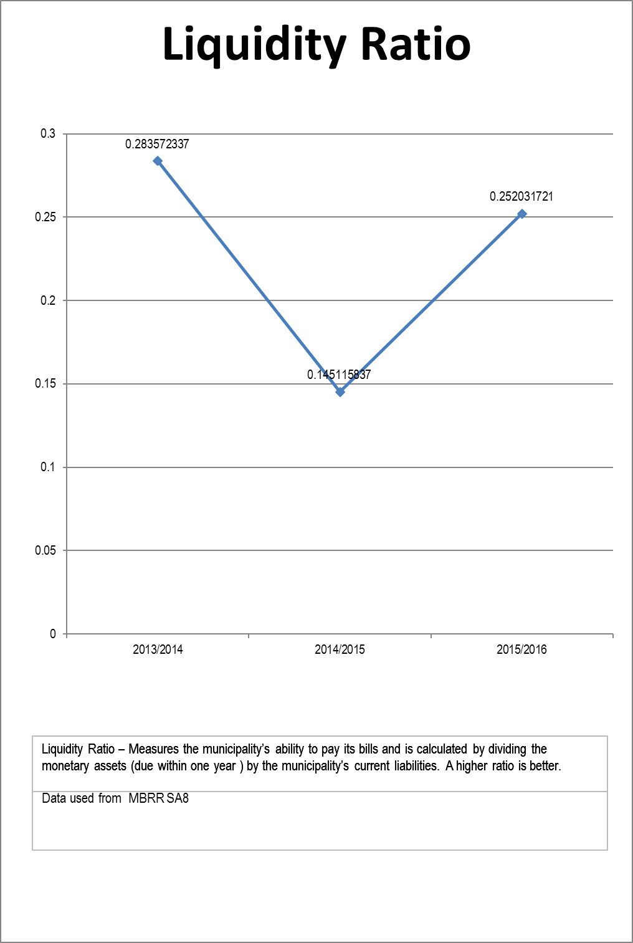

T 5.4.1

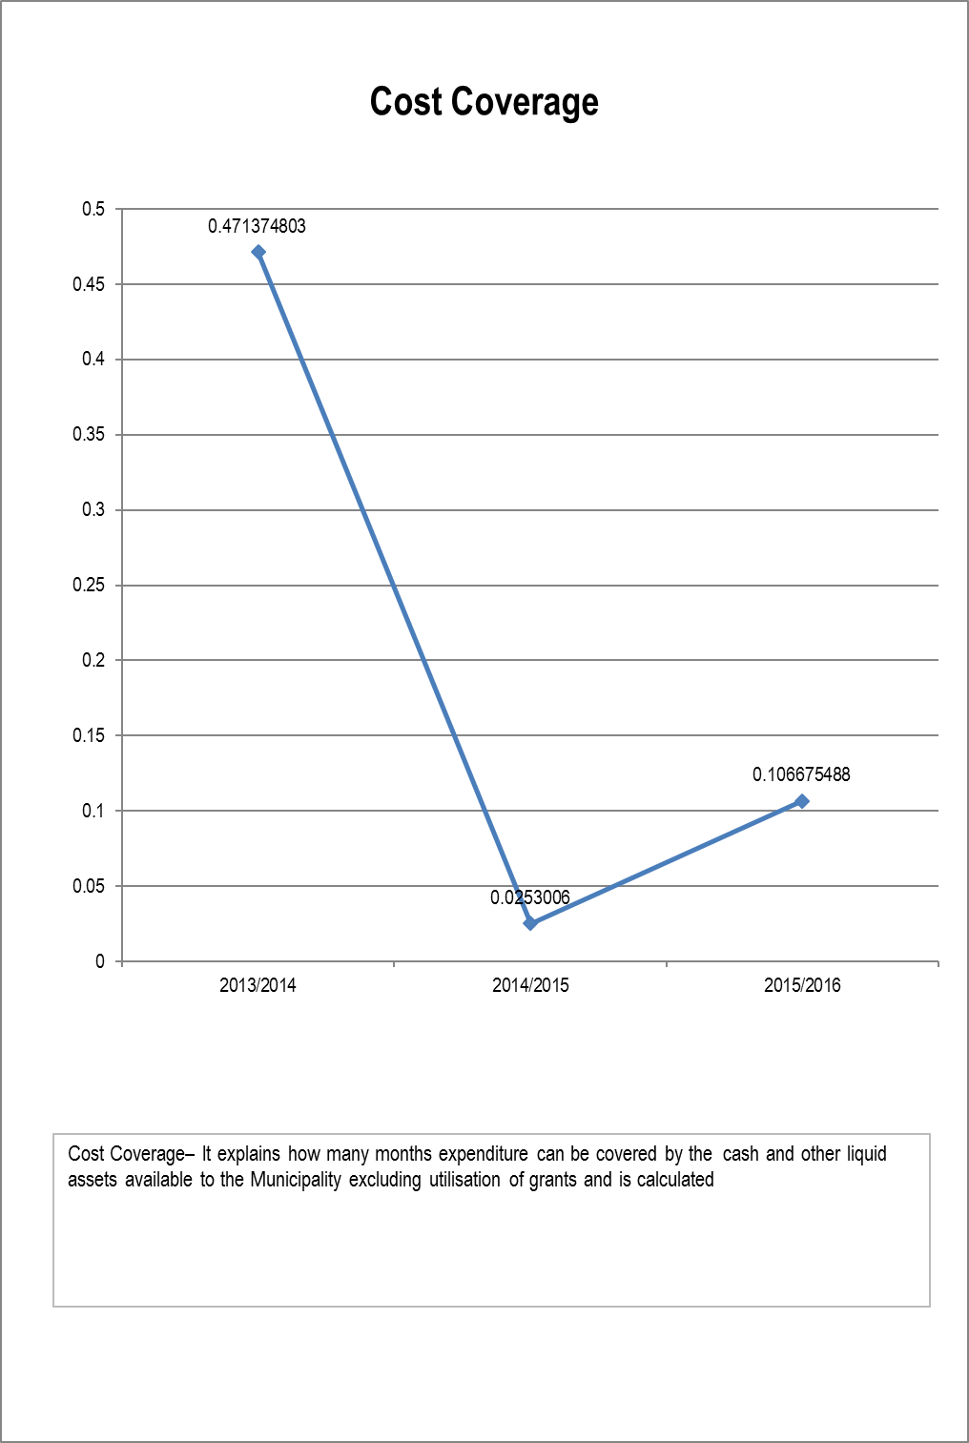
T 5.4.2

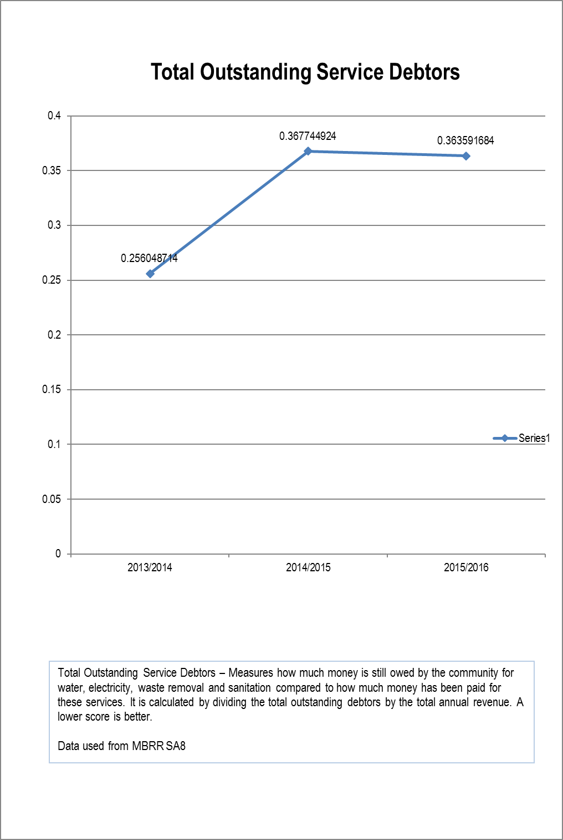
T 5.4.3
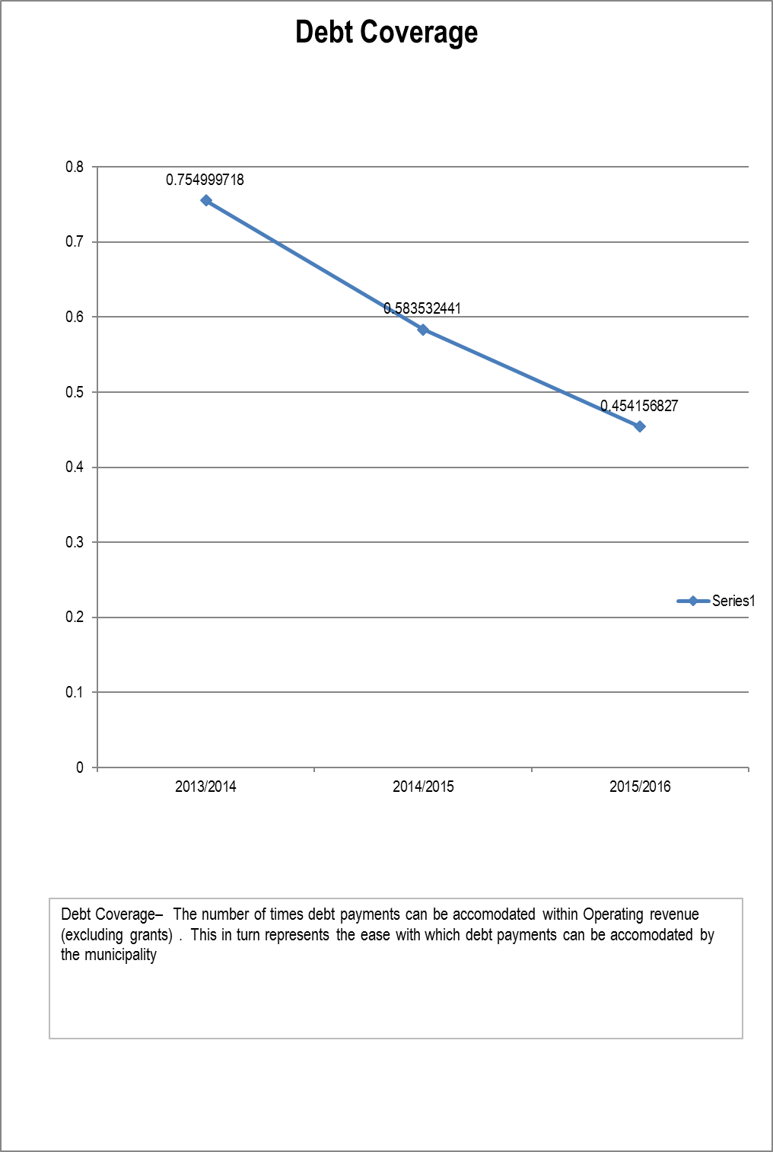
T 5.4.4

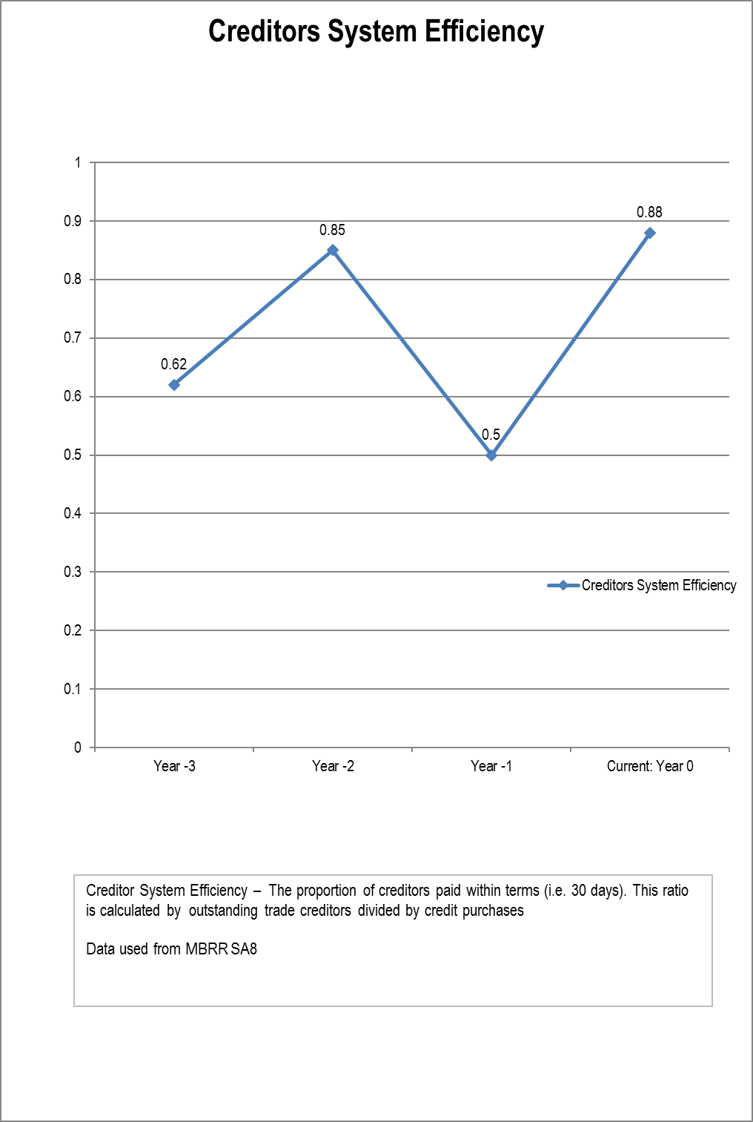
T 5.4.5

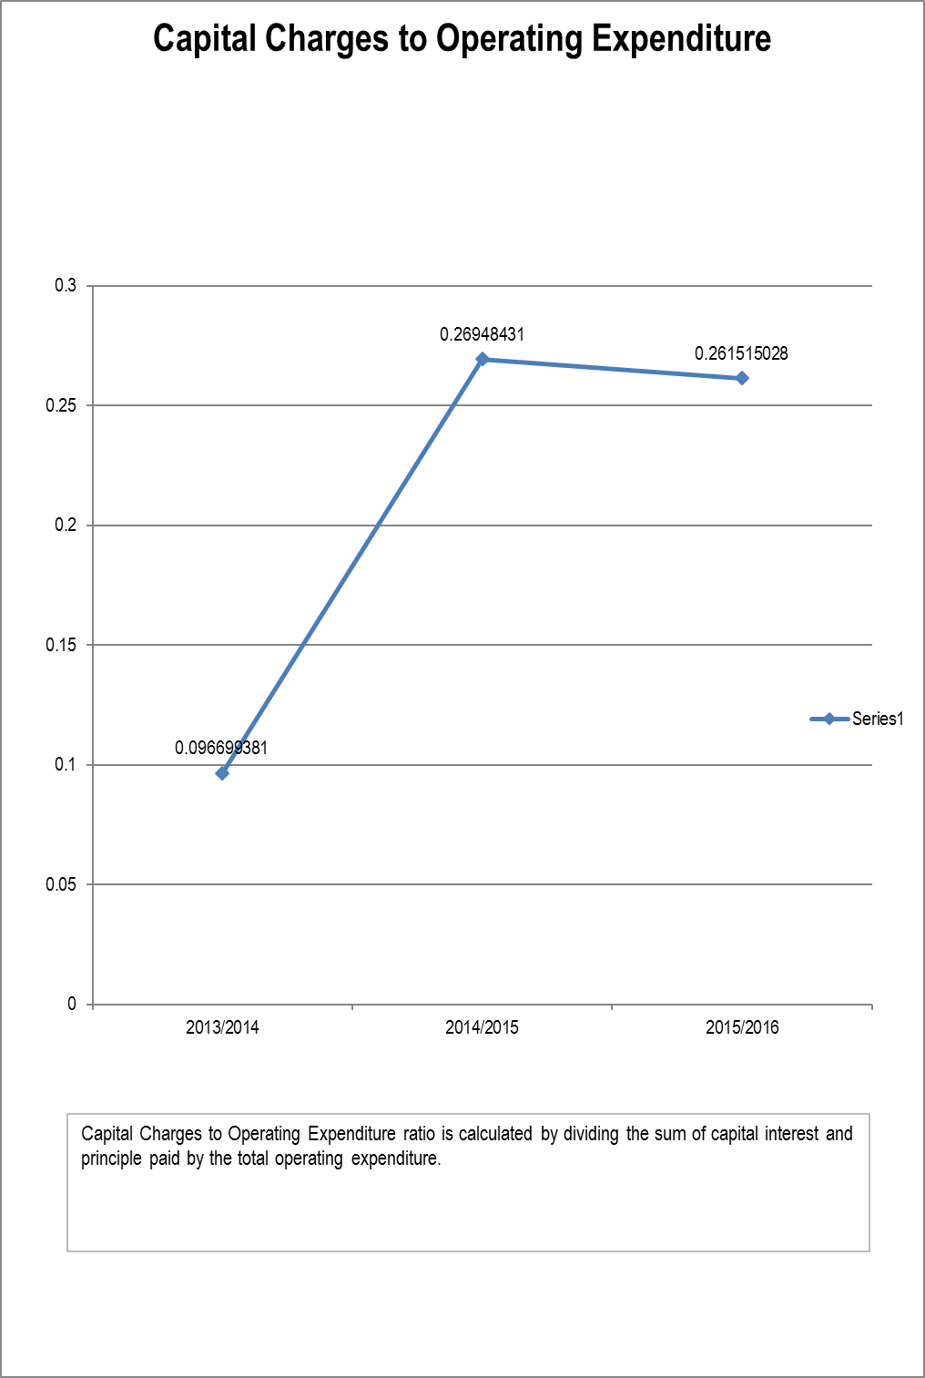
T 5.4.6

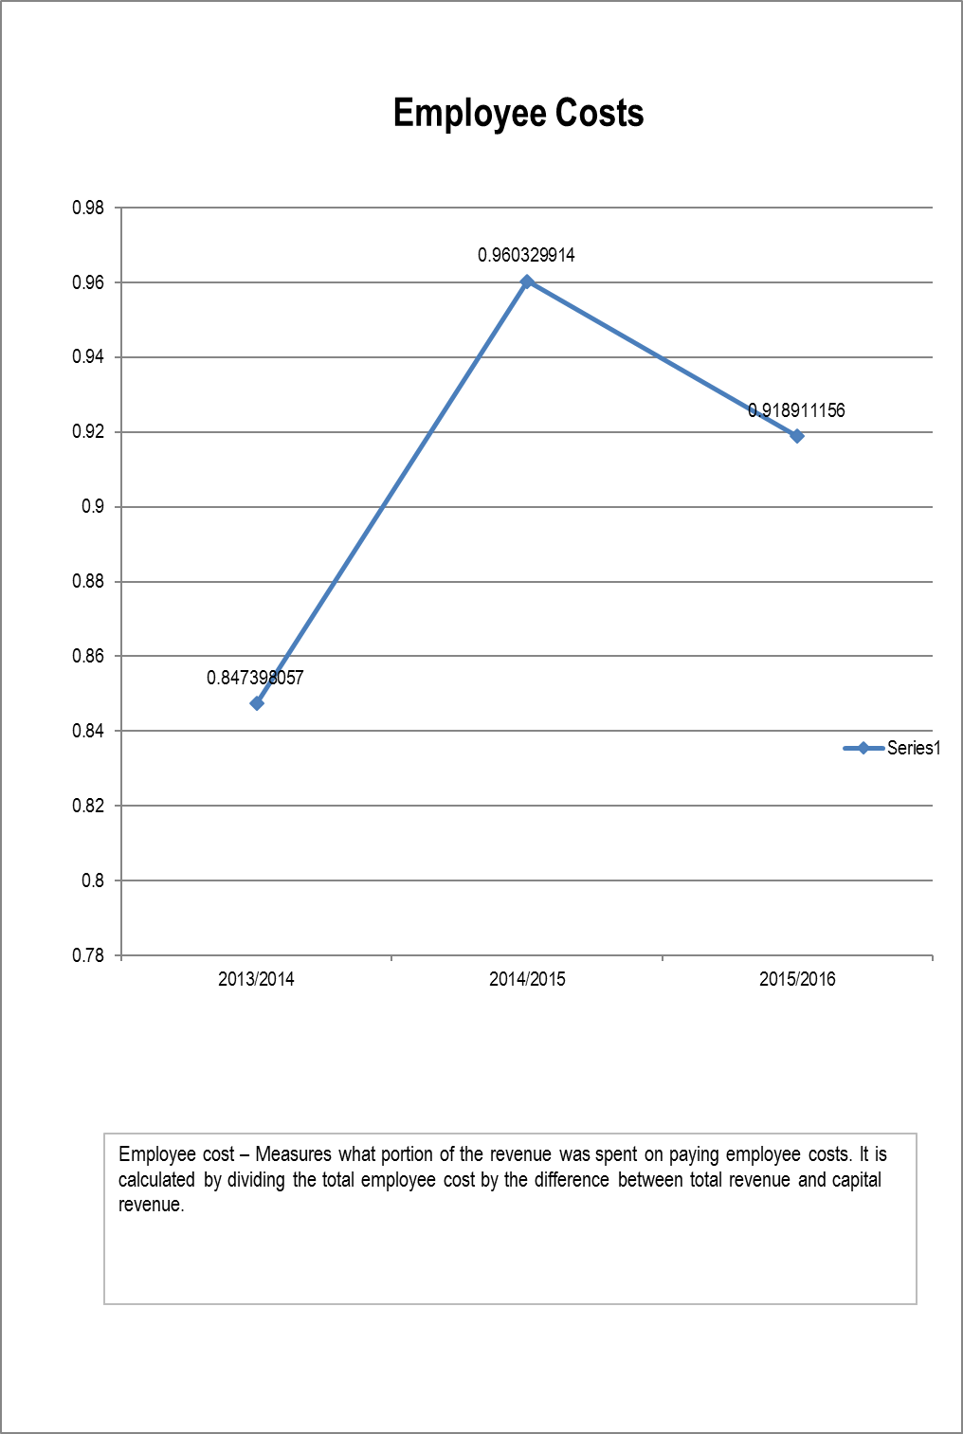
T 5.4.7

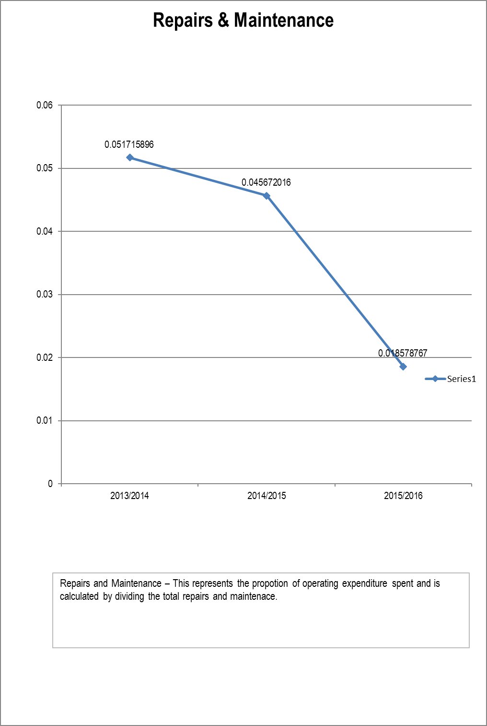
T 5.4.8

COMMENT ON FINANCIAL RATIOS:

The municipality is far below the accepted broad norms standards of which the ratios should fall into as a healthy municipality giving further evidence of the severe financial strain the municipality is finding itself within.

T 5.4.9

COMPONENT B: SPENDING AGAINST CAPITAL BUDGET

INTRODUCTION TO SPENDING AGAINST CAPITAL BUDGET

The total original capital budgeted amounted to R 17,25 million, the funding of which is from National Government.

T 5.5.0

5.5 CAPITAL EXPENDITURE

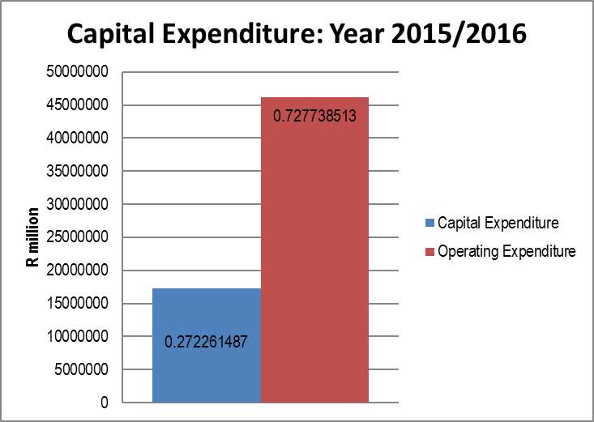
T 5.5.1

5.6 SOURCES OF FINANCE

COMMENT ON SOURCES OF FUNDING:

Funding of capital expenditure is from national government in the form of grants. Additional funding was received during the year. The variance in capital funding can be ascribed to additional RBIG funding received during the financial year.

T 5.6.1.1

5.7 CAPITAL SPENDING ON 5 LARGEST PROJECTS

COMMENT ON CAPITAL PROJECTS:

The project entailed increasing the flow of the new plant from the Orange River into the dam. Taking water from Orange River into the dam in order to assist with capacity in new areas.

T 5.7.1.1

5.8 BASIC SERVICE AND INFRASTRUCTURE BACKLOGS – OVERVIEW

INTRODUCTION TO BASIC SERVICE AND INFRASTRUCTURE BACKLOGS

The municipality is aware of backlogs in the delivery of services. No full and proper records thereto can be presented due to the nature of the backlogs. The backlogs arose due to the severe financial constraints that the municipality is under and was thus unable to deliver services to the affected areas.

T 5.8.1

COMMENT ON BACKLOGS:

There are a number of ways that backlogs can be addressed. One of those ways is updating the municipality’s indigent register which can then serve as the basis for additional funding to enable the provision of electricity.

T 5.8.4

COMPONENT C: CASH FLOW MANAGEMENT AND INVESTMENTS

INTRODUCTION TO CASH FLOW MANAGEMENT AND INVESTMENTS

Strict cash measures have been introduced to control the flow of money & what it is being used for at the municipality. This is evident in the cash and cash equivalents held at the end of the financial year.

The Municipality concluded a big project this current year which final payments to suppliers which affected the cash flow of the municipality

Compared to the precious financial year, the net cash from operating activities increased from R13.5 million to R21.2 million which is very excellent.

T 5.9

5.9 CASH FLOW

COMMENT ON CASH FLOW OUTCOMES:

The net cash movement in Investing activities decreased to R17.4 million from previous financial year’s R20.6 million.

The Financing activities stayed relatively the same compared to previous year which were R1.04 million and R1.24 million this current year.

T 5.9.1.1

5.10 BORROWING AND INVESTMENTS

INTRODUCTION TO BORROWING AND INVESTMENTS

Borrowings decreased this year as loans were being paid off by the municipality. There was also a decrease in Bank loans as the current one is only from Standard Bank Investment.

T 5.10.1

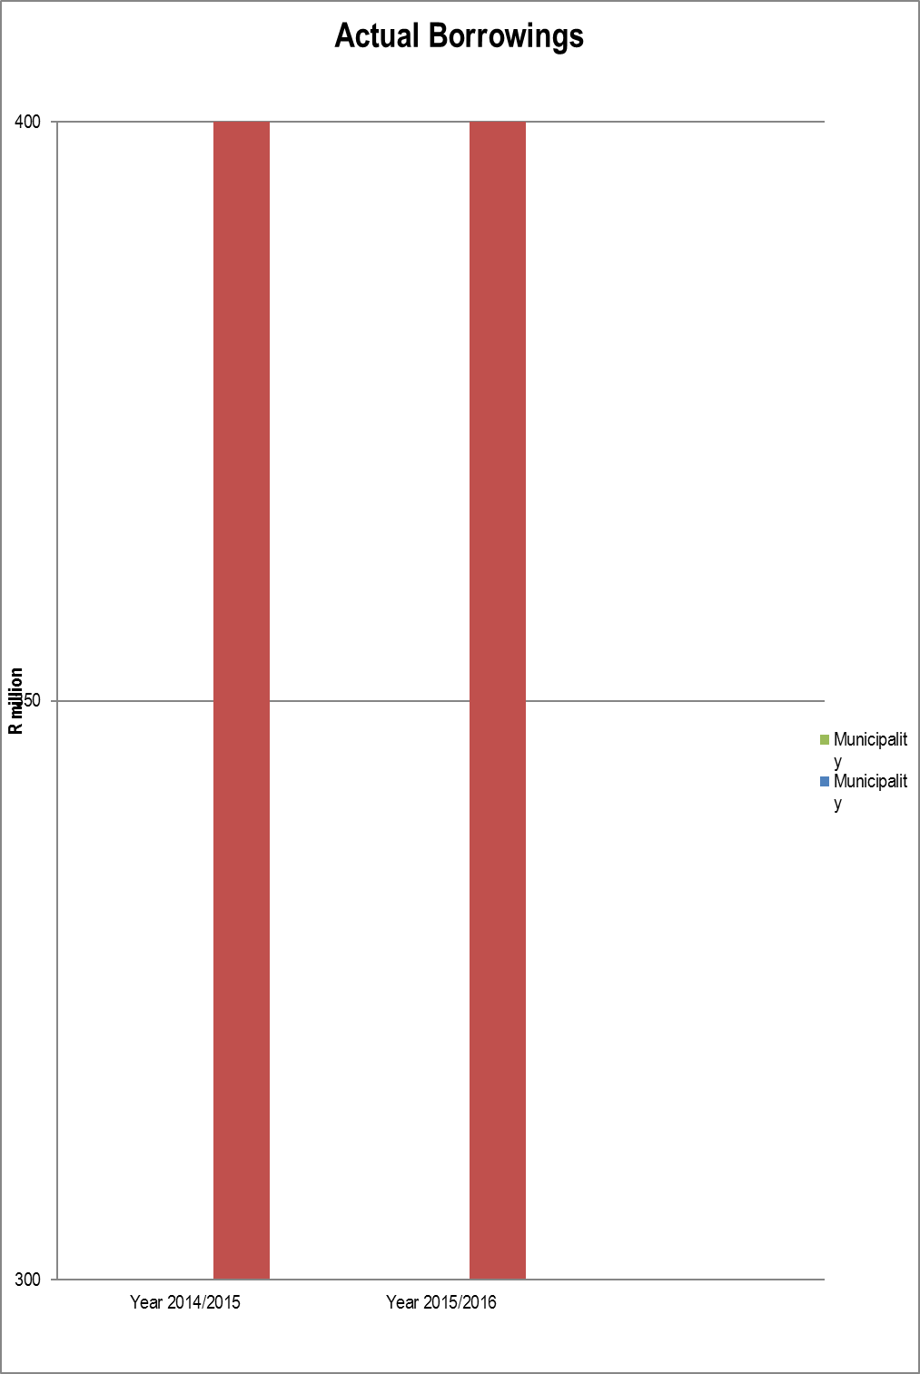
T 5.10.3

COMMENT ON BORROWING AND INVESTMENTS:
The municipality has done well in decreasing the loans as ideally it should fund itself from the collection of services provided. The Municipality has an investment at Standard Bank which gathers good interest. The municipality does not grant loans in cash or otherwise to organizations as aforementioned in the financial performance it is in severe financial stress at the moment.
T 5.10.5

5.11 PUBLIC PRIVATE PARTNERSHIPS

PUBLIC PRIVATE PARTNERSHIPS

The Municipality does not have any Public Private Partnerships currently for the 2015/2016 financial year.
T 5.11.1

COMPONENT D: OTHER FINANCIAL MATTERS

5.12 SUPPLY CHAIN MANAGEMENT

SUPPLY CHAIN MANAGEMENT

The Municipality has a fully functional Supply Chain Management (SCM) Unit. All SCM committees have been established and meet regularly. Minor audit issues were raised during the financial year and will be addressed in the Audit Action Plan.

The Municipality has a fully functional Supply Chain Management (SCM) Unit. All SCM committees have been established and meet regularly. Minor audit issues were raised during the financial year and will be addressed in the Audit Action Plan.
T 5.12.1

5.13 GRAP COMPLIANCE

GRAP COMPLIANCE

Generally Recognized Accounting Practice provides the rules by which municipalities are required to maintain their financial accounts. Successful GRAP compliance will ensure that municipal accounts are comparable and more informative for the municipality. It will also ensure that the municipality is more accountable to its citizens and other stakeholders. Information on GRAP compliance is needed to enable National Treasury to assess the pace of progress and consider the implications.

The financial statements have been prepared in accordance with these standards including any interpretations, guidelines and directives issued by the Accounting Standards Board.
The financial statements are based upon appropriate accounting policies consistently applied and supported by reasonable and prudent judgements and estimates.
T 5.13.1

CHAPTER 6 – AUDITOR GENERAL AUDIT FINDINGS

INTRODUCTION

The Annual Financial Statements are set out in Volume II of the annual report. These statements have
been audited by the Auditor General and a Qualified Audit Opinion was achieved. The AG report is also included in this Annual Report.

T 6.0.1

COMPONENT A: AUDITOR-GENERAL OPINION OF FINANCIAL STATEMENTS Year -1

6.1 AUDITOR GENERAL REPORTS Year -1 (Previous year)

COMPONENT B: AUDITOR-GENERAL OPINION YEAR 0 (CURRENT YEAR)

6.2 AUDITOR GENERAL REPORT YEAR 0

AUDITOR GENERAL REPORT ON THE FINANCIAL STATEMENTS: YEAR 0

Introduction

1. I have audited the financial statements of Thembelihle Local Municipality set on pages ... and … which comprise of the statement of financial position as at 30 June 2016, the cash flow statement and statement of comparison of budget and actual amounts for the year ended, as well as notes, comprising a summary of significant accounting policies and explanatory information.
Accounting officer’s responsibility for the financial statements

2. The accounting officer is responsible for the preparation and fair presentation of these financial statements in accordance of with South African Standards of Generally Accepted Accounting Practice (SA standards of GRAP) and requirements of the Municipal Finance Management Act of South Africa, 2003 (Act No. 56 of 2003) (MFMA) and Division of Revenue Act of South Africa, 2015 (Act No. 1 of 2015) (DoRA), and for such internal control as the accounting officer determines is necessary to enable the preparation of financial statements that are free from material misstatement, whether due to fraud or error.
Auditor-general’s responsibility

3. My responsibility is to express an opinion on these financial statements based on my audit. I conducted my audit in accordance with International Standards on Auditing. Those standards require that I comply with ethical requirements, and plan and perform the audit to obtain reasonable assurance about whether the financial statements are free from material misstatement.

4. An audit involves performing procedures to obtain audit evidence about the amounts and disclosures in the financial statements. The procedures selected depend on the auditor's judgement, including the assessment of the risks of material misstatement of the financial statements, whether due to fraud or error. In making those risk assessments, the auditor considers internal control relevant to the entity's preparation and fair presentation of the financial statements in order to design audit procedures that are appropriate in the circumstances, but not for the purpose of expressing an opinion on the effectiveness of the entity's internal control. An audit also includes evaluating the appropriateness of accounting policies used and the reasonableness of accounting estimates made by management, as well as evaluating the overall presentation of the financial statements.

5. I believe that the audit evidence I have obtained is sufficient and appropriate to provide a basis for my qualified audit opinion.

Basis for qualified audit opinion

Revenue from non-exchange transactions

6. The municipality did not have adequate systems in place to account for the revenue from conditional grants in accordance with GRAP 23, Revenue from non-exchange transactions because there were differences between the amount that is disclosed as government grants and subsidies in note 35 and the amount disclosed in the statement of financial performance as revenue from the government grants and subsidies. The effect on the financial statements was that revenue from non-exchange transactions was overstated by R 7 061 510. Additionally, there is a consequential impact on the surplus for the period and on the accumulated surplus.

7. The municipality did not measure revenue from non-exchange transactions (fines, penalties and forfeits) in accordance with GRAP 23, Revenue from non-exchange transactions and iGRAP,1 Applying the probability test on initial recognition of revenue, because the municipality recognized revenue from non-exchange transactions (fines, penalties and forfeits) on a cash basis. Additionally I was unable to obtain sufficient appropriate audit evidence for fines, penalties and forfeits because I could not trace the receipts of fines to the general ledger. I could not confirm the fines, penalties and forfeits by alternative means. Consequently, I was unable to determine whether any adjustment to revenue from non-exchange transactions (fines, penalties and forfeits) stated at R609 645 (2015: R3 466 184) in note 36 to the financial statements.
8. I was unable to obtain sufficient appropriate audit evidence whether the municipality amended or prepared the supplementary valuation roll during the year in accordance with section 77 of the Municipal Property Rates Act (MPRA), 2004 (Act No. 6 of 2004). I was unable to confirm the property rates by alternative means. Consequently, I was unable to determine whether any adjustment to property rates and receivables from non-exchange transactions stated at R3 137 037 and R717 925 in notes 34 and 5 respectively, in the financial statements were necessary.

Receivables from non-exchange transactions

9. I was unable to obtain sufficient appropriate audit evidence regarding receivables from non-exchange transactions (fines, penalties and forfeits) and the related provision for doubtful debts due to the status of the accounting records and non-submission of the supporting documentation. I was unable to confirm the receivables from non-exchange transactions (fines, penalties and forfeits) and the related provision by alternative means. Consequently, I was unable to determine whether any adjustment relating to receivables from non-exchange transactions (fines, penalties and forfeits) stated at R3 460 741(2015: R3 720 000) and the related provision stated at R2 917 054(2015: R2 917 054) in note 5 to the financial statements was necessary.

Property Plant and equipment

10. The municipality did not assess whether there is any indication that property, plant and equipment might be impaired in accordance with GRAP 26, Impairment of cashgenerating assets. The effect on the financial statements was that property plant and equipment was understated by R5 875 984. Additionally, there was a resultant impact on the surplus for the period and on the accumulated surplus.

Unspent conditional grants and receipts

11. The municipality did not have adequate systems in place to properly account for unspent conditional grants and receipts in note 21 to the financial statements. The effect on the financial statements was that the unspent conditional grants and receipts were understated by R4 882 489. In addition I was unable to obtain sufficient appropriate audit evidence that the Regional Bulk Infrastructure Grant (RBIG) had been properly accounted for. I was unable to confirm the RBIG by alternative means. Consequently, I was unable to determine whether any adjustment to unspent conditional grants and receipts stated at R1 389 682 (2015: R6 785 456) in note 21 to the financial statements was necessary.

Commitments

12. I was unable to obtain sufficient appropriate audit evidence regarding commitments contracted but not yet provided for as the municipality did not have adequate systems to maintain records of commitments. I was unable to confirm the commitments contracted but not yet provided for by alternative means. Consequently, I was unable to determine whether any adjustment relating to the commitments contracted but not yet provided for stated at R21 327 819 in note 52 of the financial statements was necessary.
Budget comparison

13. The municipality did not have adequate systems in place to properly account for budgeted amounts disclosed in the statement of comparison of budget and actual amounts in accordance with GRAP 24; Presentation of budget information in financial statements, because the municipality used the figures from the prior year budget. The impact on the financial statements is that variances analysis will not be correct.

Aggregation of immaterial uncorrected misstatements

14. The financial statements were materially misstated due to the cumulative effect of numerous individually immaterial uncorrected misstatements in the following items included in the statement of financial position and the statement of financial performance:

• Expenditure reflected as R17 713 597 was overstated by R2 339 058

In addition, I was unable to obtain sufficient appropriate audit evidence and to confirm the following items by alternative means:

• Expenditure of R1 835 838 as included in the disclosed balance of R17 713 597

Consequently, I was unable to determine whether any adjustment to these items was necessary.

Qualified opinion

15. In my opinion, except for the effects of the matters described in the basis for qualified opinion paragraphs, the financial statements present fairly, in all material respects, the financial position of the Thembelihle Local Municipality as at 30 June 2016 and its financial performance and cash flows for the year then ended, in accordance with the SA standards of GRAP and the requirements of the MFMA and DoRA.

Emphasis of matters

16. I draw attention to the matters below. My opinion is not modified in respect of these matters:
Irregular expenditure

17. As disclosed in note 61 to the financial statements, the municipality incurred irregular expenditure amounting to R23 984 767 (2015: R 7 416 312) in contravention of supply chain management laws and regulations.

Restatement of corresponding figures

18. As disclosed in note 55 of the financial statements, the corresponding figures for 30 June 2015 have been restated as a result of an error discovered during 2016 in the financial statements of the municipality at, and for the year ended, 30 June 2015.

Significant uncertainties

19. With reference to note 53 of the financial statements, the municipality is the defendant in a litigation process pertaining to traffic revenue. No response has been received from the claimant. The ultimate outcome of this matter cannot presently be determined and no provision for any liability that may result has been made in the financial statements.
Material losses

20. As disclosed in note 64 and 65 to the financial statements, material losses were reported at 56% (2015: 58%) and 36% (2015: 49%) incurred as a result of distribution losses relating to unaccounted water and electricity, respectively.
Additional matters

21. I draw attention to the matters below. My opinion is not modified in respect of these matters.

Unaudited disclosure notes

22. In terms of section 125(2) (e) of the MFMA, the municipality is required to disclose particulars of non-compliance with the MFMA. This disclosure requirement did not form part of the audit of the financial statements and accordingly we do not express an opinion thereon.

Unaudited supplementary schedules

23. The supplementary information set out on pages XX to XX does not form part of the financial statements and is presented as additional information. I have not audited these schedule(s) and, accordingly, we do not express an opinion thereon.
Report on other legal and regulatory requirements

24. In accordance with the Public Audit Act of South Africa, 2004 (Act No. 25 of 2004) and the general notice issued in terms thereof, I have a responsibility to report findings on the reported performance information against predetermined objectives of selected development priorities presented in the annual performance report, compliance with legislation and internal control. The objective of my tests was to identify reportable findings as described under each sub-heading but not to gather evidence to express assurance on these matters. Accordingly, I do not express an opinion or conclusion on these matters.

Predetermined objectives

25. The annual performance report of the municipality was not presented for auditing and consequently my findings below are limited to the procedures performed in respect of the following selected development priorities as contained in the strategic planning and performance management documents:

a. Development Priority 1: Local Economic Development on pages xx to xx
b. Development Priority 2: Basic Service delivery on pages xx to xx
c. Development Priority 3: Municipal Transformation and Institutional Development on pages xx to xx
26. I assessed the information to determine whether the performance indicators and targets were well defined, verifiable, specific, measurable, time bound and relevant, as required by the National Treasury's Framework for managing programme performance information (FMPPI).

27. The material findings in respect of the selected development priorities are as follows:

Development Priority 1: Local Economic Development

Usefulness of performance information

Measurability of indicators and targets

28. The measurability of 100% of the planned targets and indicators could not be assessed due to a lack of technical indicator descriptions and proper systems and processes, as the municipality does not have an individual responsible for the management of performance information.

Relevance of indicators and targets

29. The FMPPI requires indicators to relate logically and directly to an aspect of the auditee’s mandate and the realisation of strategic goals and objectives. The relevance of 100% indicators could not be assessed due to a lack of corroborative supporting evidence to verify management's explanation why the indicators were considered important and relevant to the realisation of strategic goals and objectives.

Development Priority 2: Basic Service delivery

Usefulness of performance information

Measurability of indicators and targets

30. The measurability of 100% of the planned targets and indicators could not be assessed due to a lack of technical indicator descriptions and proper systems and processes, as the municipality does not have an individual responsible for the management of performance information.
Relevance of indicators and targets

31. The FMPPI requires indicators to relate logically and directly to an aspect of the auditee’s mandate and the realisation of strategic goals and objectives. The relevance of 100% indicators could not be assessed due to a lack of corroborative supporting evidence to verify management's explanation why the indicators were considered important and relevant to the realisation of strategic goals and objectives.

Development Priority 3: Municipal Transformation and Institutional Development

Usefulness of performance information

Measurability of indicators and targets

32. The measurability of 100% of the planned targets and indicators could not be assessed due to a lack of technical indicator descriptions and proper systems and processes, as the municipality does not have an individual responsible for the management of performance information.

Relevance of indicators and targets

33. The FMPPI requires indicators to relate logically and directly to an aspect of the auditee’s mandate and the realisation of strategic goals and objectives. The relevance of 100% indicators could not be assessed due to a lack of corroborative supporting evidence to verify management’s explanation why the indicators were considered important and relevant to the realisation of strategic goals and objectives.

Compliance with legislation

34. I performed procedures to obtain evidence that the municipality had complied with applicable legislation regarding financial matters, financial management and other related matters. My material findings on compliance with specific matters in key legislation, as set out in the general notice issued in terms of the PAA, are as follows:

Strategic planning and performance management

35. The adopted IDP did not reflect and identify the key performance indicators and targets as required by sections 26 and 41 of the Municipal Systems Act, as well as Municipal planning and performance management regulation 2(1) and 2(3) (a-c).

36. Performance targets were not set for each of the key performance indicators for the financial year as required by section 41(1)(b) of the MSA and the Municipal planning and performance management regulations 12(1) and 12(2)(e).

37. The IDP was not drafted by taking into account the integrated development processes and proposals submitted by the district municipality as required by section 29(3)(b) of the MSA.

38. The municipality did not establish a performance management system as required by section 38(a) of the MSA or the Municipal planning and performance management regulation (8)

Financial statements, performance and annual reports

39. The financial statements submitted for auditing were not prepared in all material respects in accordance with the requirements of section 122 of the MFMA. Material misstatements of payables identified by the auditors in the submitted financial statements were subsequently corrected and/or the supporting records were provided subsequently, but the uncorrected material misstatements and/ or supporting records that could not be provided resulted in the financial statements receiving a qualified audit opinion.
40. The 2014/15 annual report was not tabled in the municipal council within seven months after the end of the financial year, as required by section 127(2) of the MFMA.

41. The annual performance report was not prepared for the financial period under review, as required by section 46 of the MSA.

Procurement and contract management

42. Goods and services with a transaction value of below R200 000 were procured without obtaining the required price quotations, in contravention of SCM regulation 17(a) and (c).

43. Quotations were accepted from prospective providers who were not on the list of accredited prospective providers and did not meet the listing requirements prescribed by the SCM policy, in contravention of SCM regulations 16(b) and 17(b).

44. Contracts were awarded to providers whose tax matters had not been declared by the South African Revenue Service to be in order, in contravention of SCM regulation 43.

45. Contracts were awarded to bidders who did not submit a declaration on whether they are employed by the state or connected to any person employed by the state, as required by SCM regulation 13(c).

46. The performance of contractors or providers was not monitored on a monthly basis, as required by section 116(2)(b) of the MFMA.

47. The preference point system was not applied in all procurement of goods and services above R30 000, as required by section 2(a) of the Preferential Procurement Policy Framework Act and SCM regulation 28(1)(a).

Human resource management and compensation

48. The competencies of the head of supply chain, financial and supply chain management officials were not assessed in a timely manner in order to identify and address gaps in competency levels as required by Municipal Regulations on Minimum Competency Levels 13.

49. Sufficient appropriate audit evidence could not be obtained that newly appointed managers directly accountable to municipal managers submitted original or certified copies of academic and professional qualifications, proof of previous employment and disclosure of financial interests prior to appointment as per the requirements of regulation 4 of GNR 805.

50. The senior managers directly accountable to the municipal manager did not sign performance agreements, as required by section 57(2)(a) of the Municipal Systems Act.

51. The municipality did not develop and adopt appropriate systems (policies) and procedures to monitor measure and evaluate performance of staff in contravention of section 67(d) of the Municipal Systems Act.
Expenditure management

52. Reasonable steps were not taken to prevent irregular expenditure and fruitless and wasteful expenditure, as required by section 62(1)(d) of the MFMA.

53. Money owed by the municipality was not always paid within 30 days, as required by section 65(2)(e) of the MFMA.

Conditional grants received

54. The municipality did not evaluate its performance in respect of programmes funded by the Municipal Infrastructure Grant (MIG) and Regional Bulk Infrastructure Grant (RBIG) allocation, as required by section 12(5) of the DoRA.

Asset management

55. An effective system of internal control for assets (including an asset register) was not in place, as required by section 63(2)(c) of the MFMA.

Consequence management

56. Unauthorised expenditure incurred by the municipality was not investigated to determine if any person is liable for the expenditure, as required by section 32(2)(a) of the MFMA.

57. Irregular and fruitless and wasteful expenditure incurred by the municipality was not investigated to determine if any person is liable for the expenditure, as required by section 32(2)(b) of the MFMA.

Internal control

58. I considered internal control relevant to my audit of the financial statements, and compliance with legislation. The matters reported below are limited to the significant internal control deficiencies that resulted in the basis for qualified opinion, the findings on compliance with legislation included in this report.

Leadership

59. Although the municipality has an MM, the CFO position was left vacant for the major part of the financial year and the other senior manager’s positions were also vacant. The leadership instability and breakdown of the internal control structures within the municipality has impacted the operations of the municipality negatively.

60. The vacancies in key senior management positions have contributed to the dire situation at the municipality as no measures were taken to prevent unauthorised, irregular and fruitless and wasteful expenditure or investigate this expenditure once incurred.
61. Leadership did not exercise oversight responsibility regarding financial and performance reporting, compliance and related internal controls as there were repeat findings on financial statements, compliance with regulations and performance information. Adequate time has not been set aside by the accounting officer and acting CFO to ensure that all internal controls are working as intended.

62. There are no standard operating procedures in place that will assist in ensuring the validity, accuracy, completeness and consistency of performance information reporting, with respect to service delivery. This is evident because the annual performance report was not submitted for audit purposes.

63. Action plans to address the external audit findings were not developed and implemented timeously. Adherence to the plan was not effectively monitored by an appropriate level of management. This has resulted in recurring financial, non-compliance and performance management findings in the current year.

Financial and performance management

64. In terms of our engagement letter, we agreed that all information requested for purposes of the audit would be submitted within 3 working days of the request by the auditors.
Despite this agreement, management did not supply the documentation within the agreed upon timeframes.

65. Proper record keeping was not implemented in a timely manner to ensure that complete, relevant and accurate information is accessible and readily available to support financial and performance reporting. Supporting documentation required to support revenue, revenue, non-current assets and commitments was not provided.

66. Controls over daily and monthly processing and reconciling of transactions were not implemented for non-current assets, revenue, expenditure and commitments. Management did not prepare regular, accurate and complete financial and performance reports that are supported and evidenced by reliable information for revenue, non- current assets and commitments. In addition, officials involved in the process of setting targets, defining indicators, collecting and reporting on performance information are not able to effectively and completely articulate the systems governing the performance measures in writing. This is evident because the annual performance report was not submitted for audit purposes.

67. The financial statements contained numerous misstatements that were not corrected. This was mainly due to staff members not fully understanding the requirements of the financial reporting framework.

Governance

68. Leadership did not conduct a risk assessment and ensure that the municipality had an operational audit committee that monitored the effectiveness of internal audit and ensured that the approved plan is adequately implemented.

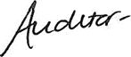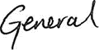

Kimberly,
13 December 2016

T 6.2.3

COMMENTS ON AUDITOR-GENERAL’S OPINION YEAR 0:

Audit Action Plan is attached.
T 6.2.4

COMMENTS ON MFMA SECTION 71 RESPONSIBILITIES:

Section 71 of the MFMA requires municipalities to return a series of financial performance data to the National Treasury at specified intervals throughout the year. The Chief Financial Officer states that these data sets have been returned according to the reporting requirements.

Signed (Chief Financial Officer)………………………………………………………..... Dated
T 6.2.5

GLOSSARY

Accessibility indicators | Explore whether the intended beneficiaries are able to access services or outputs.
Accountability documents | Documents used by executive authorities to give “full and regular” reports on the matters under their control to Parliament and provincial legislatures as prescribed by the Constitution. This includes plans, budgets, in-year and Annual Reports.
Activities | The processes or actions that use a range of inputs to produce the desired outputs and ultimately outcomes. In essence, activities describe "what we do".
Adequacy indicators | The quantity of input or output relative to the need or demand.
Annual Report | A report to be prepared and submitted annually based on the regulations set out in Section 121 of the Municipal Finance Management Act. Such a report must include annual financial statements as submitted to and approved by the Auditor-General.
Approved Budget | The annual financial statements of a municipality as audited by the Auditor General and approved by council or a provincial or national executive.
Baseline | Current level of performance that a municipality aims to improve when setting performance targets. The baseline relates to the level of performance recorded in a year prior to the planning period.
Basic municipal service | A municipal service that is necessary to ensure an acceptable and reasonable quality of life to citizens within that particular area. If not provided it may endanger the public health and safety or the environment.
Budget year | The financial year for which an annual budget is to be approved – means a year ending on 30 June.
Cost indicators | The overall cost or expenditure of producing a specified quantity of outputs.
Distribution indicators | The distribution of capacity to deliver services.
Financial Statements | Includes at least a statement of financial position, statement of financial performance, cash-flow statement, notes to these statements and any other statements that may be prescribed.
General Key performance indicators | After consultation with MECs for local government, the Minister may prescribe general key performance indicators that are appropriate and applicable to local government generally.
Impact | The results of achieving specific outcomes, such as reducing poverty and creating jobs.
Inputs | All the resources that contribute to the production and delivery of outputs. Inputs are "what we use to do the work". They include finances, personnel, equipment and buildings.
Integrated Development Plan (IDP) | Set out municipal goals and development plans.
National Key performance areas | - Service delivery & infrastructure  - Economic development  - Municipal transformation and institutional development  - Financial viability and management  - Good governance and community participation
Outcomes | The medium-term results for specific beneficiaries that are the consequence of achieving specific outputs. Outcomes should relate clearly to an institution's strategic goals and objectives set out in its plans. Outcomes are "what we wish to achieve".
Outputs | The final products, or goods and services produced for delivery. Outputs may be defined as "what we produce or deliver". An output is a concrete achievement (i.e. a product such as a passport, an action such as a presentation or immunization, or a service such as processing an application) that contributes to the achievement of a Key Result Area.
Performance Indicator | Indicators should be specified to measure performance in relation to input, activities, outputs, outcomes and impacts. An indicator is a type of information used to gauge the extent to  which an output has been achieved (policy developed, presentation delivered, service rendered)
Performance Information | Generic term for non-financial information about municipal services and activities. Can also be used interchangeably with performance measure.
Performance Standards: | The minimum acceptable level of performance or the level of performance that is generally accepted. Standards are informed by legislative requirements and service-level agreements. Performance standards are mutually agreed criteria to describe how well work must be done in terms of quantity and/or quality and timeliness, to clarify the outputs and related activities of a job by describing what the required result should be. In this EPMDS performance standards are divided into indicators and the time factor.
Performance Targets: | The level of performance that municipalities and its employees strive to achieve. Performance Targets relate to current baselines and express a specific level of performance that a municipality aims to achieve within a given time period.
Service Delivery Budget Implementation Plan | Detailed plan approved by the mayor for implementing the municipality’s delivery of services; including projections of the revenue collected and operational and capital expenditure by vote for each month. Service delivery targets and performance indicators must also be included.
Vote: | One of the main segments into which a budget of a municipality is divided for appropriation of money for the different departments or functional areas of the municipality. The Vote specifies the total amount that is appropriated for the purpose of a specific department or functional area.  Section 1 of the MFMA defines a “vote” as:  a) one of the main segments into which a budget of a municipality is divided for the appropriation of money for the different departments or functional areas of the municipality; and  b) which specifies the total amount that is appropriated for the purposes of the department or functional area concerned

APPENDICES

APPENDIX A – COUNCILLORS; COMMITTEE ALLOCATION AND COUNCIL ATTENDANCE

The above percentages are based on the attendance of scheduled ordinary Council meetings, as well as non-scheduled special Council meeting. The combined total amount of meetings is 8.

Councilors attended meetings fairly well throughout the year.

Those who could not attend certain meetings, submitted apologies for non-attendance.

Councilor P Louw passed away in May 2016 and was replaced by Councilor H Gosa to handle the Technical Services Portfolio.

T A.1

APPENDIX B – COMMITTEES AND COMMITTEE PURPOSES

APPENDIX C –THIRD TIER ADMINISTRATIVE STRUCTURE

APPENDIX D – FUNCTIONS OF MUNICIPALITY / ENTITY

APPENDIX E – WARD REPORTING

APPENDIX F – WARD INFORMATION

APPENDIX G – RECOMMENDATIONS OF THE MUNICIPAL AUDIT COMMITTEE YEAR 0

APPENDIX H – LONG TERM CONTRACTS AND PUBLIC PRIVATE PARTNERSHIPS

APPENDIX I – MUNICIPAL ENTITY/ SERVICE PROVIDER PERFORMANCE SCHEDULE

APPENDIX J – DISCLOSURES OF FINANCIAL INTERESTS

APPENDIX K: REVENUE COLLECTION PERFORMANCE BY VOTE AND BY SOURCE

APPENDIX K (i): REVENUE COLLECTION PERFORMANCE BY VOTE

APPENDIX K (ii): REVENUE COLLECTION PERFORMANCE BY SOURCE

APPENDIX L: CONDITIONAL GRANTS RECEIVED: EXCLUDING MIG

COMMENT ON CONDITIONAL GRANTS EXCLUDING MIG:

Delete Directive note once comment is completed – Use this box to provide additional information on grant benefits or conditions and reasons for acceptance.
T L.1

APPENDIX M: CAPITAL EXPENDITURE – NEW & UPGRADE/RENEWAL PROGRAMMES

APPENDIX M (i): CAPITAL EXPENDITURE - NEW ASSETS PROGRAMME

APPENDIX M (ii): CAPITAL EXPENDITURE – UPGRADE/RENEWAL PROGRAMME

APPENDIX N – CAPITAL PROGRAMME BY PROJECT YEAR 0

APPENDIX O – CAPITAL PROGRAMME BY PROJECT BY WARD YEAR 0

APPENDIX P – SERVICE CONNECTION BACKLOGS AT SCHOOLS AND CLINICS

APPENDIX Q – SERVICE BACKLOGS EXPERIENCED BY THE COMMUNITY WHERE ANOTHER SPHERE OF GOVERNMENT IS RESPONSIBLE FOR SERVICE PROVISION

APPENDIX R – DECLARATION OF LOANS AND GRANTS MADE BY THE MUNICIPALITY

APPENDIX S – NATIONAL AND PROVINCIAL OUTCOMES FOR LOCAL GOVERNMENT

VOLUME II: ANNUAL FINANCIAL STATEMENTS

Herewith the Audited Annual Financial Statements (AFS) for 2015/16 as submitted to the Auditor-General.

